
COMSATS University, Islamabad Pakistan

DataSpeak AI
Software Design Specification
60% Implementation Submission
By

Umer Javed CIIT/SP23-BDS-052/ISB
Wali Ur Rehman CIIT/SP23-BDS-054/ISB
M Ali Ahsan CIIT/SP23-BDS-059/ISB

Supervisor
Mam Nusrat Shaheen

Bachelor of Science in Data Science (2023-2027)

The candidate confirms that the work submitted is their own and appropriate
credit has been given where reference has been made to the work of others

Contents
Chapter 3: Design and Architecture 1
3.1 System Architecture Overview 1
3.2 Conceptual Architecture Diagram 2
3.2.1 Technologies and Services 3
3.3 Architecture Style 3
3.3.1 Selected Target Architecture Pattern: Microservices Architecture 3
3.4 Design Models for Object Oriented Development Approach 5
3.4.1 Activity Diagrams 6
3.4.2 Class Diagram 15
3.4.3 Sequence Diagrams 16
3.4.4 State Diagrams 22
3.4.5 ERD DIAGRAM 24
Chapter 4: Implementation 25
4.1 Project Methodology and Milestone Scope 25
4.1.1 Module Inventory and Coverage 26
4.1.2 AI Module Coverage and Remaining Scope 27
4.2 Implemented Architecture and Technology Stack 28
4.2.1 Data Organization and Tenant Boundaries 29
4.3 Implementation of Selected Modules 30
4.3.1 M01 User Authentication and Identity Management 30
4.3.2 M02 Tenant Onboarding and Profile Management 30
4.3.3 M04 Database Connection and Credential Management 31
4.3.4 M11 Schema Discovery and Metadata Management 31
4.3.5 M06 API Key Generation and Lifecycle Management 32
4.3.6 M07 Chatbot Widget SDK and Frontend Integration 32
4.3.7 M10 Intent Detection and Conversation Management 33
4.3.8 M13 Query Routing and Template Selection 33
4.3.9 M12 Intelligent Table and Column Selection 34
4.3.10 M14 Query Generation, Safety Validation and Execution 34
4.3.11 M15 Result Processing and Response Generation 35
4.3.12 M17 Knowledge Base and RAG Document Search 35
4.4 Algorithms and Data Processing 36
4.4.1 Collection, Extraction and Preprocessing 36
4.4.2 Embeddings and Model Use 36
4.4.3 Principal Algorithms 37
4.5 Security Techniques 38
4.6 External APIs and Software Libraries 39
4.7 User Interface and Demonstration Workflow 40
4.7.1 Account and Database Connection Interfaces 41
4.7.2 Knowledge Base and Database Preview Interfaces 42
4.8 Deployment Configuration and Milestone Limitations 43
Chapter 5: Testing and Evaluation 44
5.1 Evaluation Approach and Test Environment 44
5.1.1 Backend Suite Results and Evidence Limits 45
5.2 Unit Testing 46
5.2.1 Streaming and Gateway Unit Tests 47
5.2.2 Frontend Unit Verification 47
5.3 Functional Testing 48
5.3.1 Conversational and Document Functional Tests 49
5.4 Business Rules Testing 50
5.4.1 Widget Session Decision Table 50
5.4.2 SQL and Tenant Access Rules 51
5.5 Integration Testing 52
5.6 Evaluation Findings and Remaining Work 53
5.7 Implementation and Test References 54

Chapter 3: Design and Architecture

This chapter presents the proposed full-system design of DataSpeak AI, including its conceptual architecture, activity diagrams, class diagram, sequence diagrams and data design. It describes the long-term system scope. Chapter 4 identifies the technology choices and module baseline implemented for the 60% submission; proposed services in this chapter do not imply that every component is deployed.

3.1 System Architecture Overview
The full-system design proposes a multi-tier, multi-tenant SaaS platform with a React dashboard, an embedded chatbot widget, API services, an AI query pipeline and data-source adapters. Qdrant, LangGraph and Stripe appear in the target design. The implemented 60% baseline instead uses a modular FastAPI application, a custom query pipeline and FAISS vector storage, as detailed in Chapter 4. Payment processing remains outside this submission scope.

3.2 Conceptual Architecture Diagram

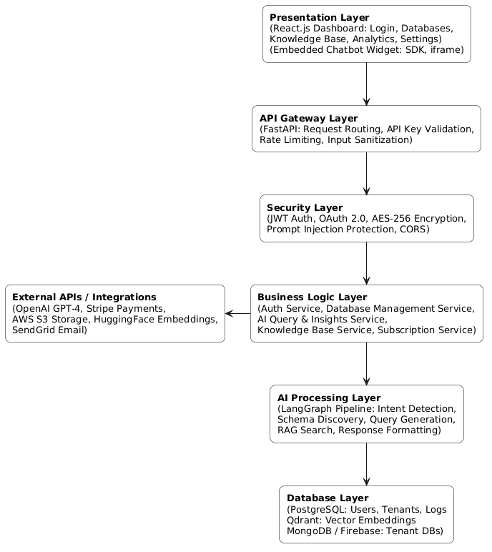
Figure 3.1 Proposed conceptual architecture of the DataSpeak AI platform

Technologies and Services
Table 3.1 Technologies, components and security mechanisms in the proposed architecture
Component | Description | Technology Used | Security / Integration
Presentation Layer | Web dashboard UI for tenants and admin | React.js, TailwindCSS | HTTPS, JWT Auth
Chatbot Widget / SDK | Embeddable JavaScript widget on client websites | Vanilla JS / CDN | API Key Auth, CORS
API Gateway | Entry point for all requests; validates API keys and enforces rate limits | FastAPI, LangGraph | Rate Limiting, API Key Validation
AI Processing Engine | Intent detection, query rewriting, semantic routing, NL response generation | LangChain, LangGraph, CrewAI, GPT-4 | Prompt Injection Protection
Database Adapter Layer | Translates natural language queries to SQL / MongoDB / Firestore | SQLAlchemy, PyMongo, Firebase SDK | AES-256 Encrypted Credentials
Knowledge Base / RAG | Vector search over uploaded PDFs, DOCX, TXT documents | Qdrant Vector DB, OpenAI Embeddings | Tenant Isolation, Namespace Separation
Billing  & Subscription | Subscription management, payment processing, usage enforcement | Stripe | PCI-Compliant Tokenization
Logging & Monitoring | Query audit trail, error tracking, usage analytics | PostgreSQL, Admin Dashboard | Role-Based Access

Architecture Style

3.3.1 Selected Target Architecture Pattern: Microservices Architecture

Microservices Architecture is the target deployment pattern for the complete platform. Separating authentication, AI processing, billing and document indexing would allow independent deployment and scaling. The current 60% implementation groups its routes and services within one modular FastAPI backend; the following design benefits describe the target architecture.
The proposed service separation provides the following design benefits:

- Independent Scalability: The AI query engine can be horizontally scaled during peak usage without scaling the billing or authentication services, reducing infrastructure costs significantly.
- Technology Diversity: Each service uses the best-fit technology — FastAPI for the AI engine, PostgreSQL for relational data, Qdrant for vector search — without forcing a single unified stack across all components.
- Fault Isolation: If the Knowledge Base indexing service goes down, the chatbot query service continues operating normally. Failures are contained within individual services and do not cascade to the entire system.
- Deployment Flexibility: Services are deployed and updated independently, enabling continuous delivery and zero-downtime deployments without requiring a full system restart.
- Clear Separation of Concerns: Each service owns a well-defined domain — authentication, query processing, billing, logging — which simplifies maintenance, testing, and team ownership.
- Clear Separation of Concerns: Each service has a well-defined responsibility, making the codebase more maintainable and allowing different teams to work on different services simultaneously.

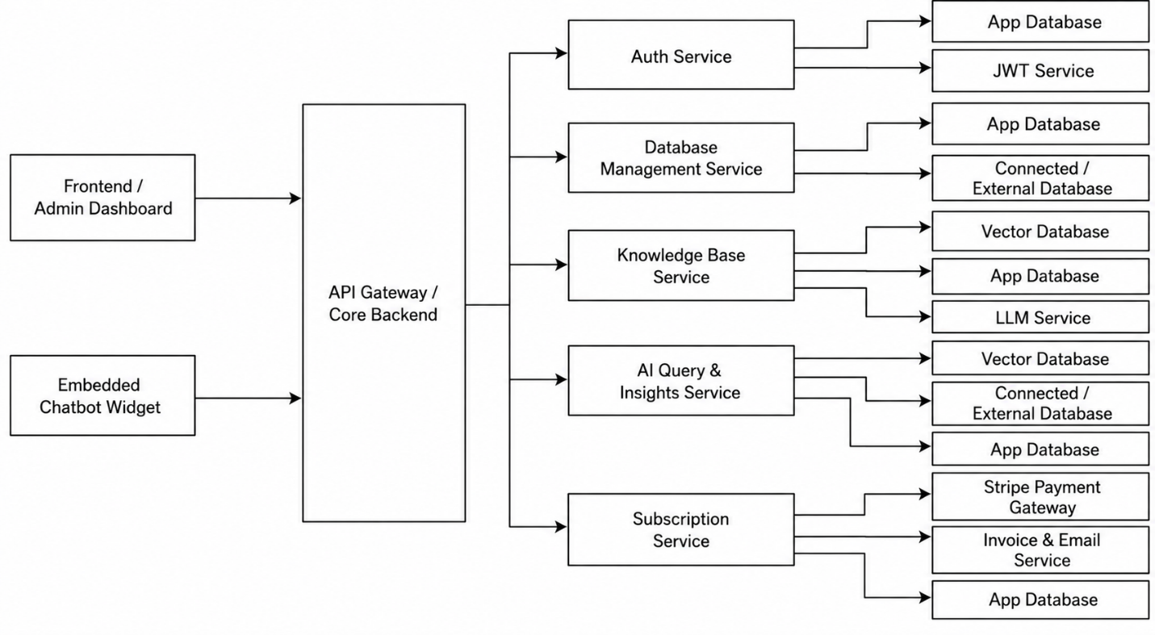

Figure 3.2 Proposed component-based microservices architecture

Interactions Among Components

Frontend (React Dashboard) ↔ API Server:

RESTful API calls handle all tenant management operations including database connections, API key management, subscription updates, and analytics retrieval.

Chatbot Widget ↔ API Gateway:

Lightweight HTTPS POST requests authenticated with the tenant's unique API key. The gateway validates rate limits before forwarding the request to the AI processing engine.
API Gateway ↔ AI Processing Engine (LangGraph): Orchestrates the multi-step query pipeline — input sanitization, intent detection, schema discovery, query generation, query execution, and response synthesis.

AI Engine ↔ Database Adapters (SQL / MongoDB / Firebase):

The query executor invokes the appropriate database adapter tool based on the discovered database type, executing the generated query securely using decrypted credentials fetched at runtime.

AI Engine ↔ Qdrant Vector DB:

For Knowledge Base queries, the user's question is converted to an embedding vector and semantically searched against the tenant's dedicated namespace in Qdrant.
API Server ↔ Stripe:
Handles subscription creation, payment webhook processing, plan upgrades with prorated billing, and automated invoice generation.

Design Models for Object Oriented Development Approach

Activity Diagrams
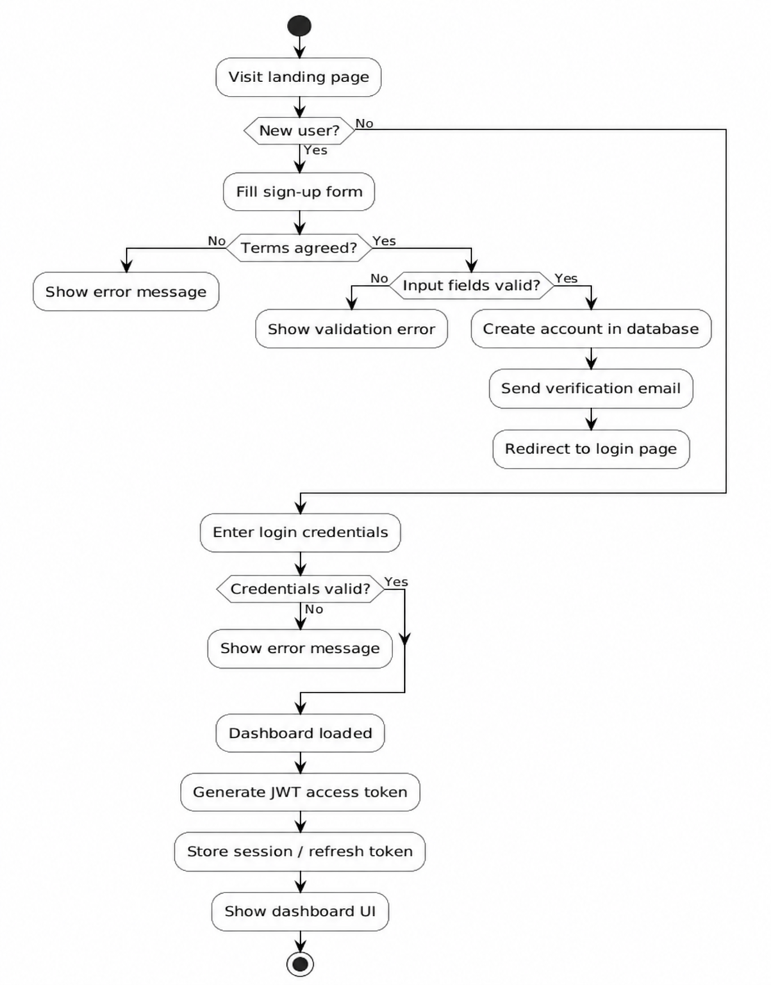
Figure 3.3 Activity Diagram for Authentication & Login Flow

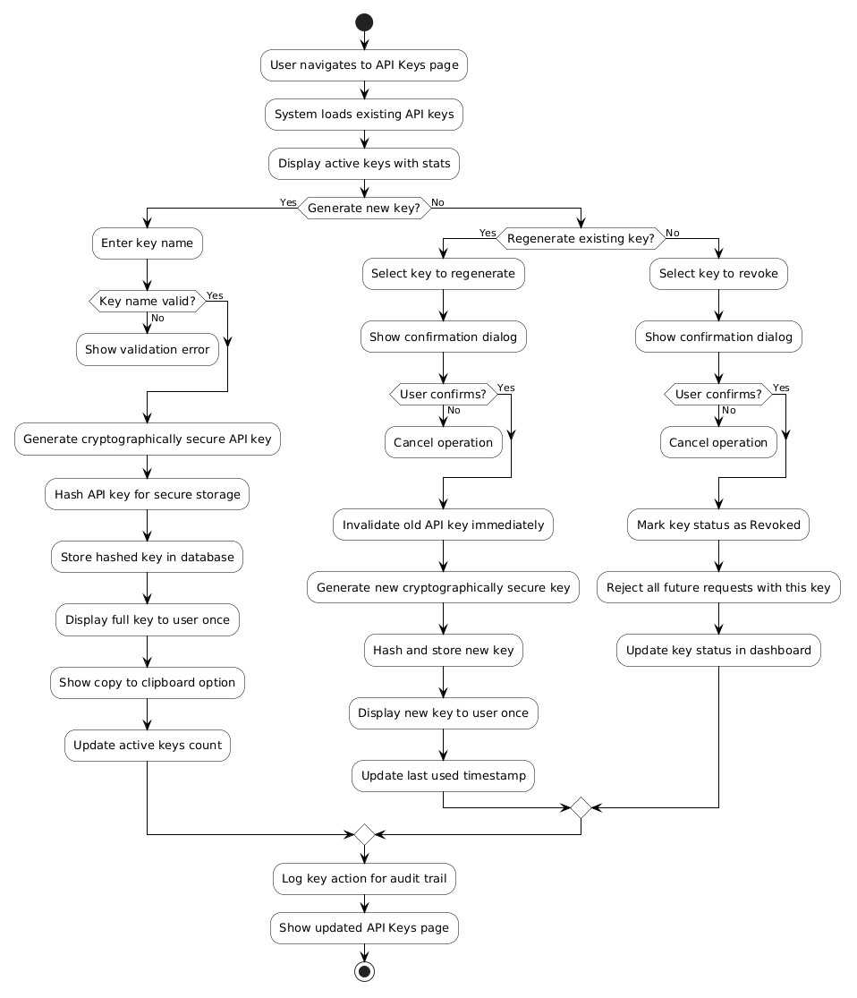
Figure 3.4 Activity Diagram for Api Key Management
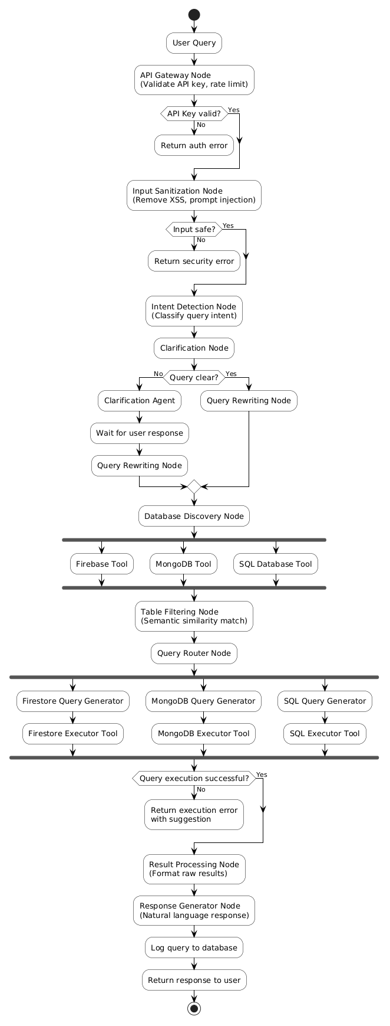
Figure 3.5 Activity Diagram for Query Processing Pipeline
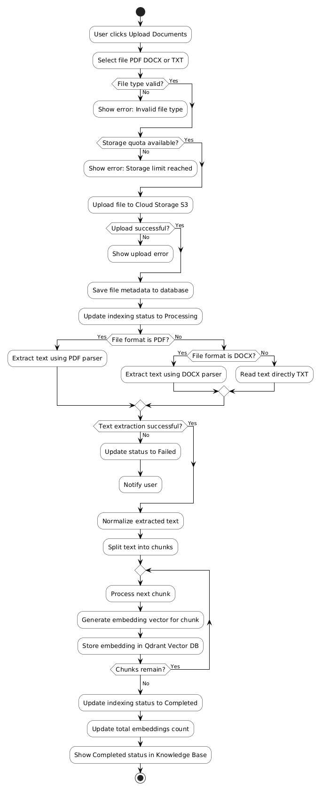
Figure 3.6 Activity Diagram for Document Uploading & Knowledge Base

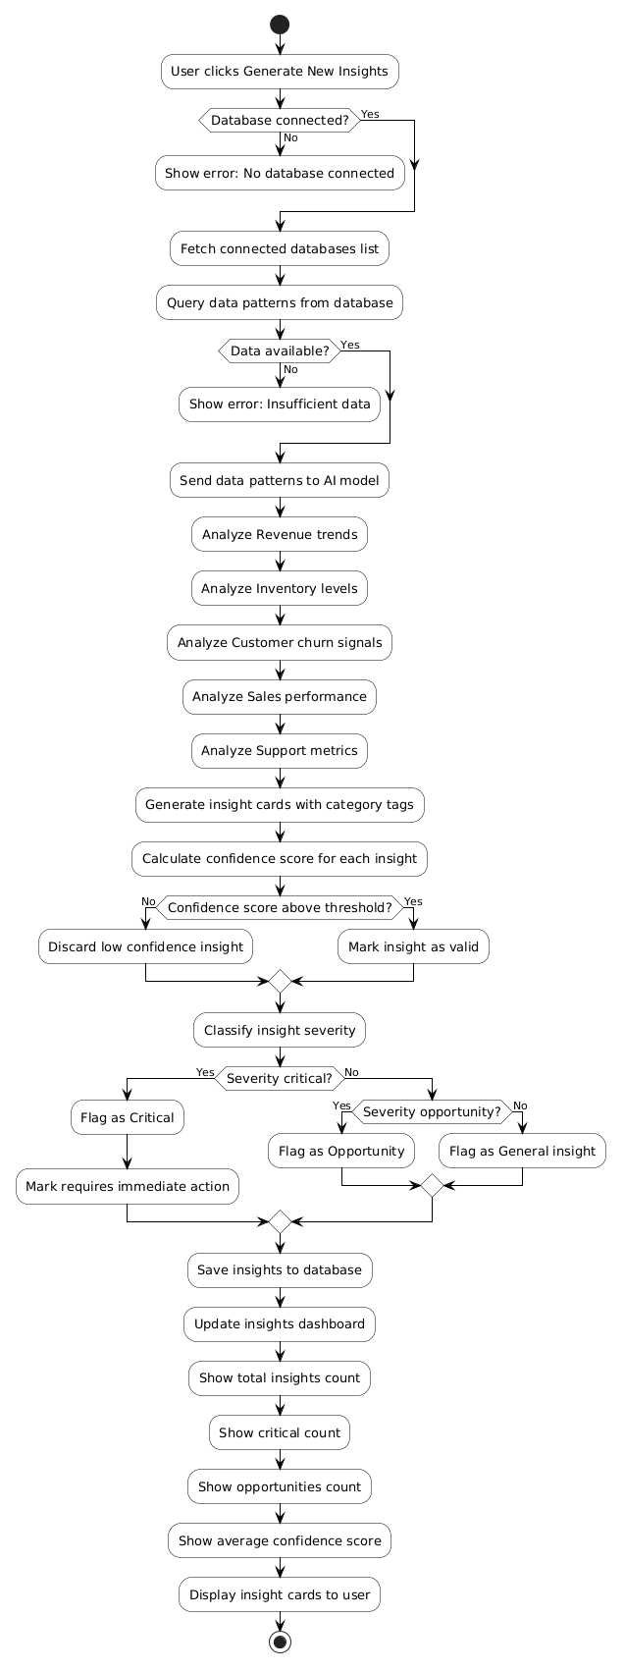

Figure 3.7 Activity Diagram for Generate new Insights
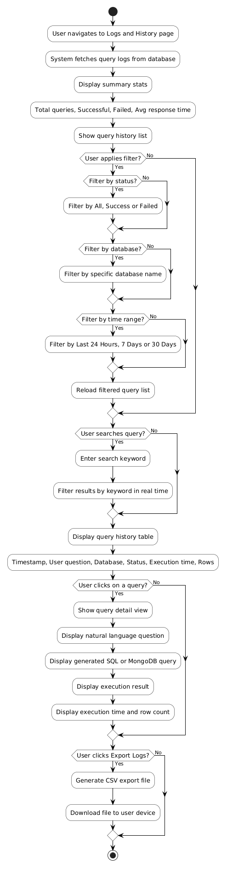
Figure 3.8 Activity Diagram for Logs And History Viewing
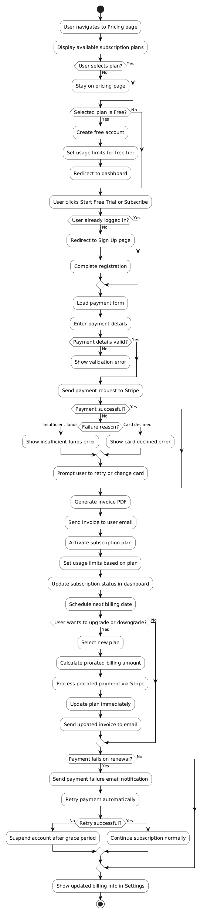
Figure 3.9 Activity Diagram for Pricing & Subscription
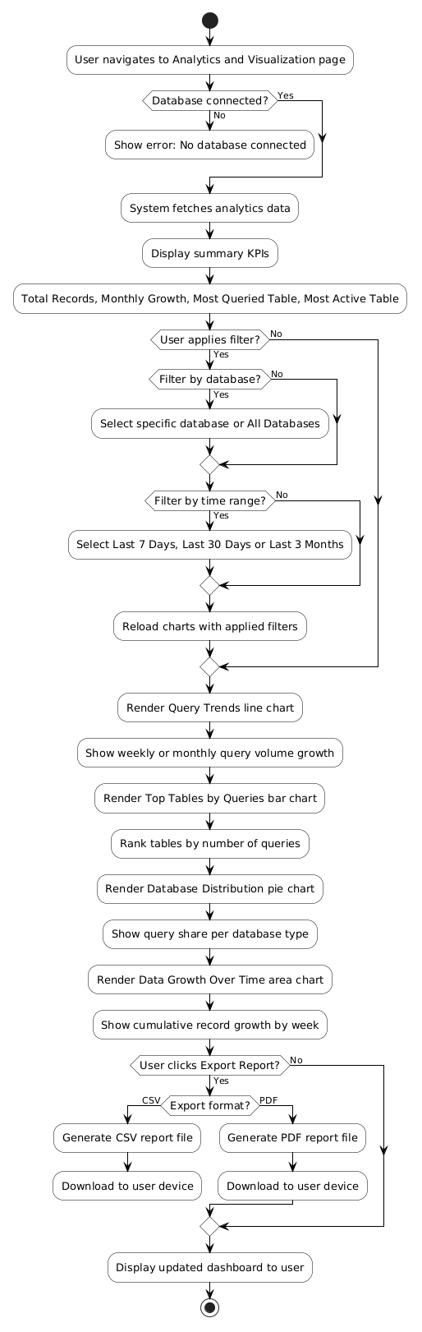
Figure 3.10 Activity Diagram for Analytics and visual Dashboard
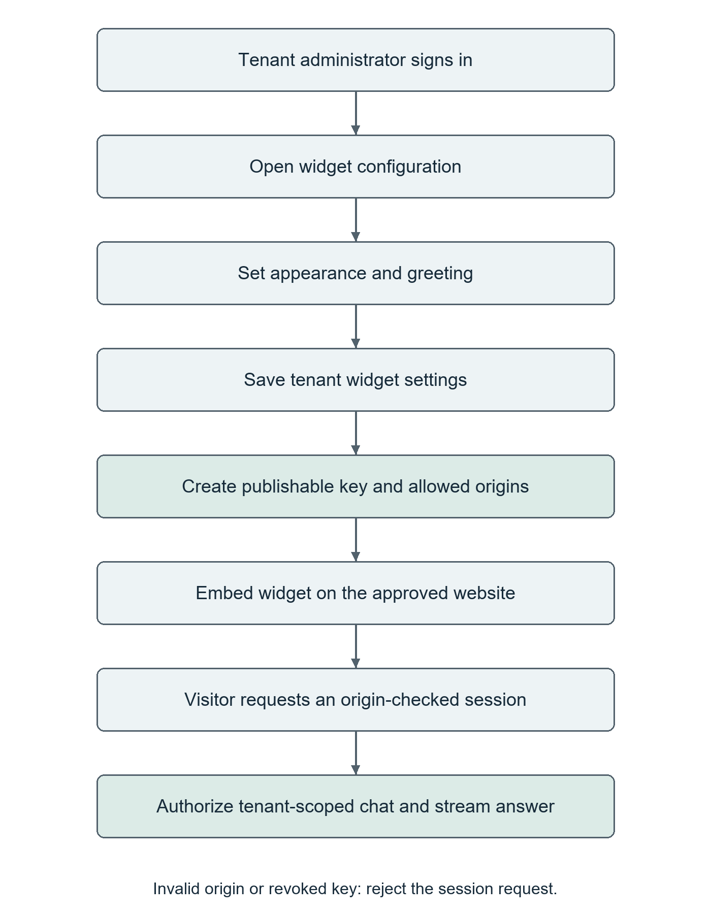
Figure 3.11 Activity Diagram for Chatbot Widget Configuration

Class Diagram

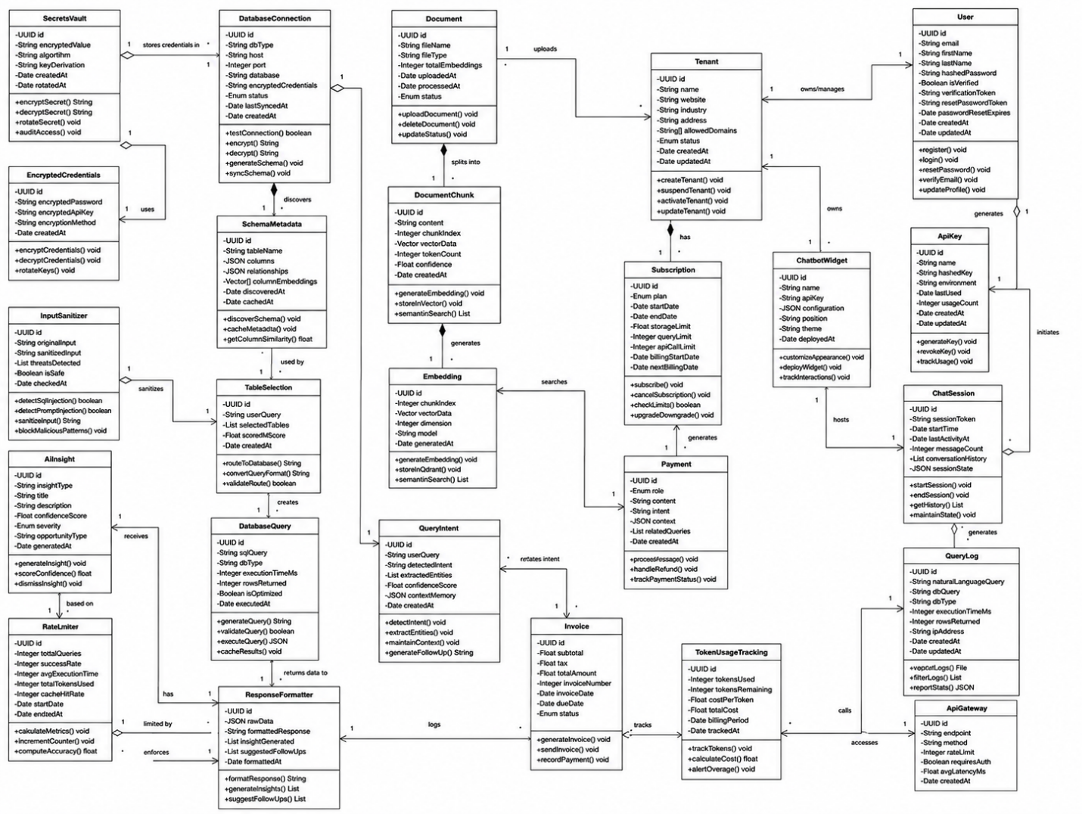

Figure 3.12 UML Class Diagram

Sequence Diagrams

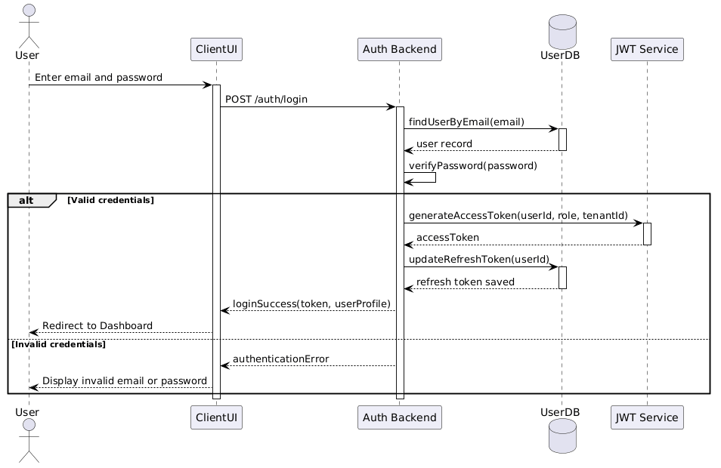

Figure 3.13 Sequence Diagram for Authentication & Login

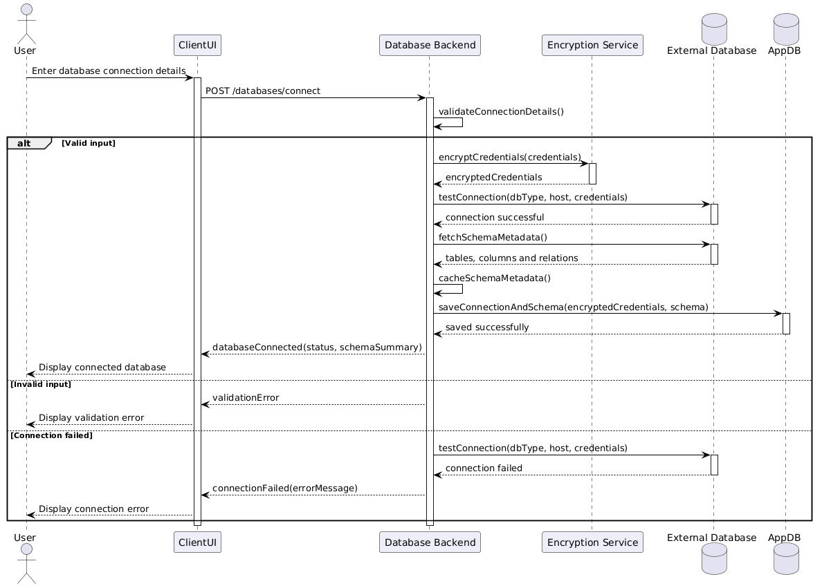

Figure 3.14 Sequence Diagram for Database Connection

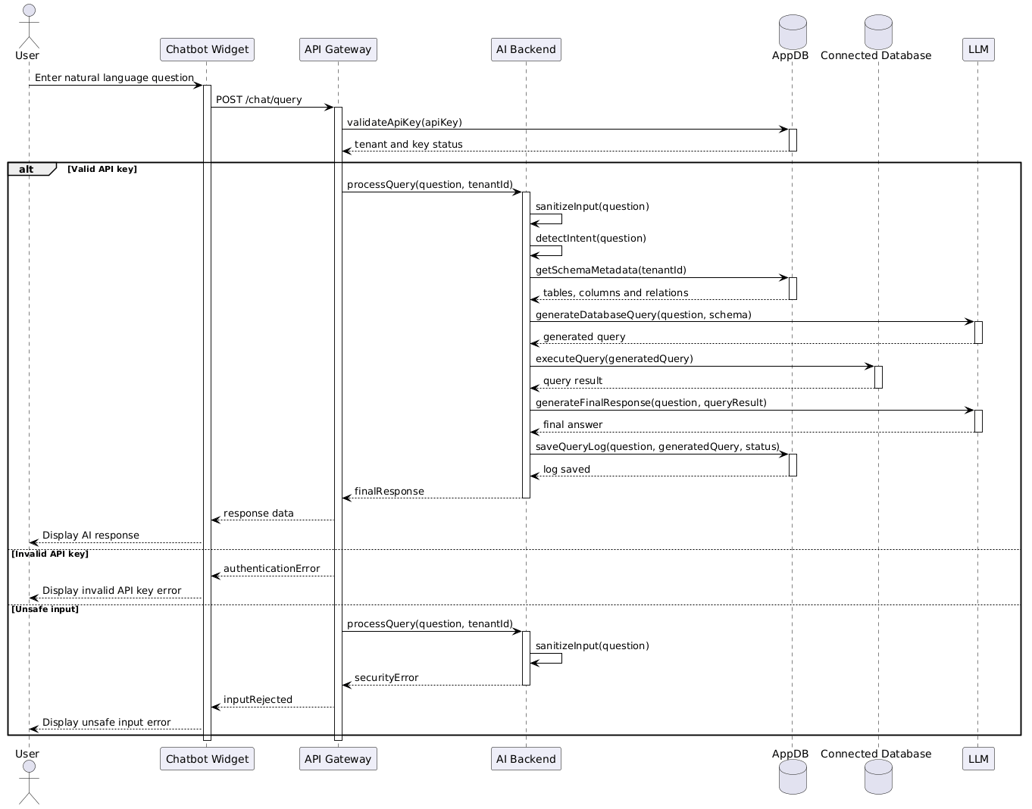

Figure 3.15 Sequence Diagram for Chatbot Widget Query

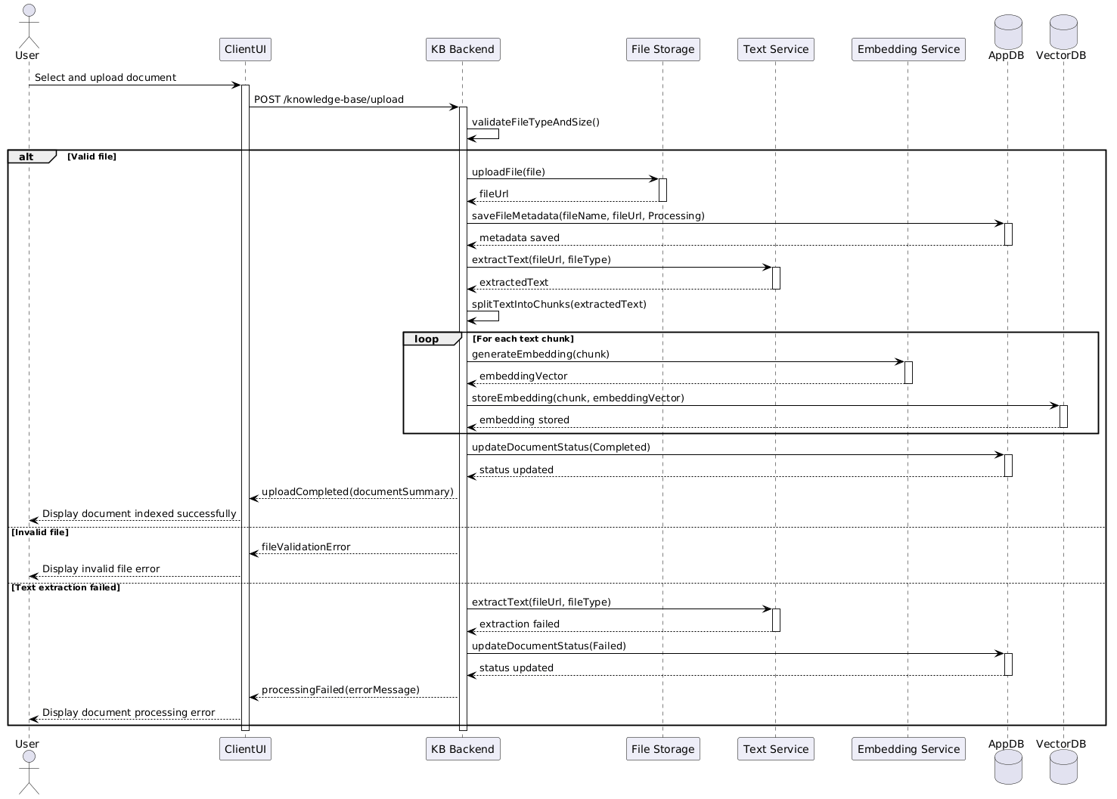
Figure 3.16 Sequence Diagram for Document Upload & Indexing

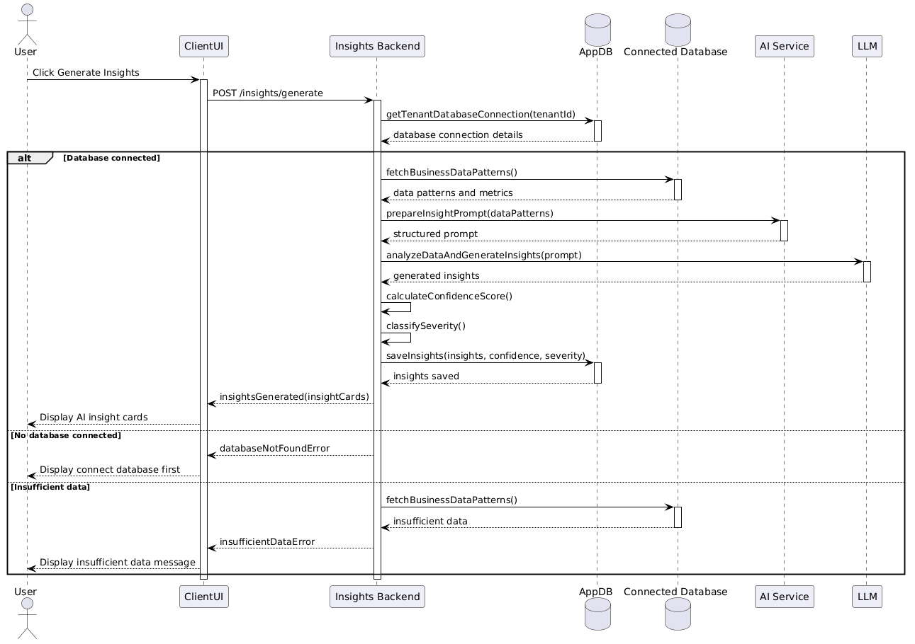

Figure 3.17 Sequence Diagram for Generate New Insights

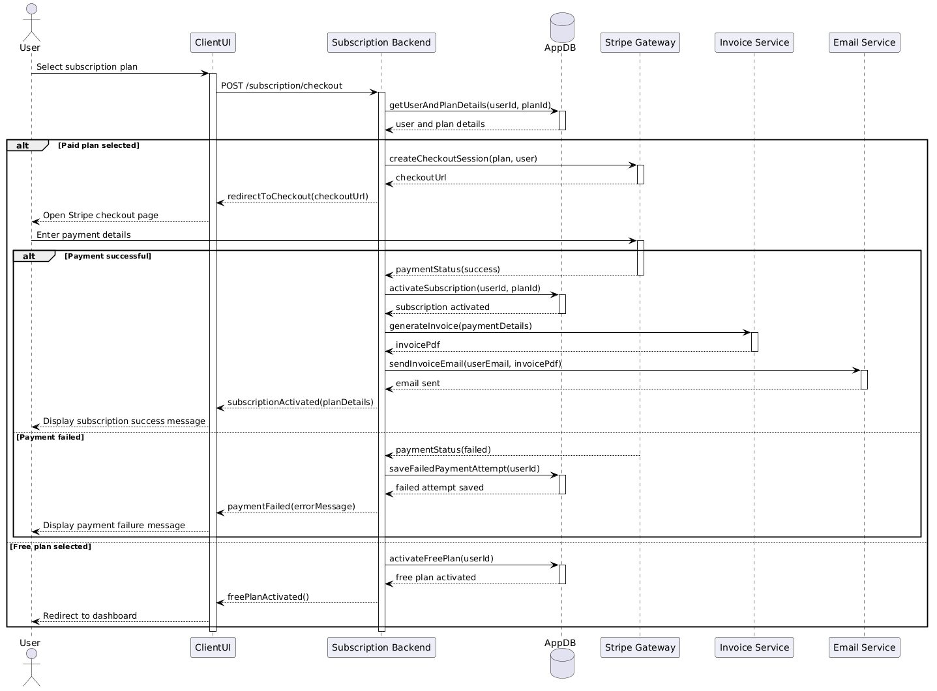

Figure 3.18 Sequence Diagram for Subscription & Checkout

State Diagrams
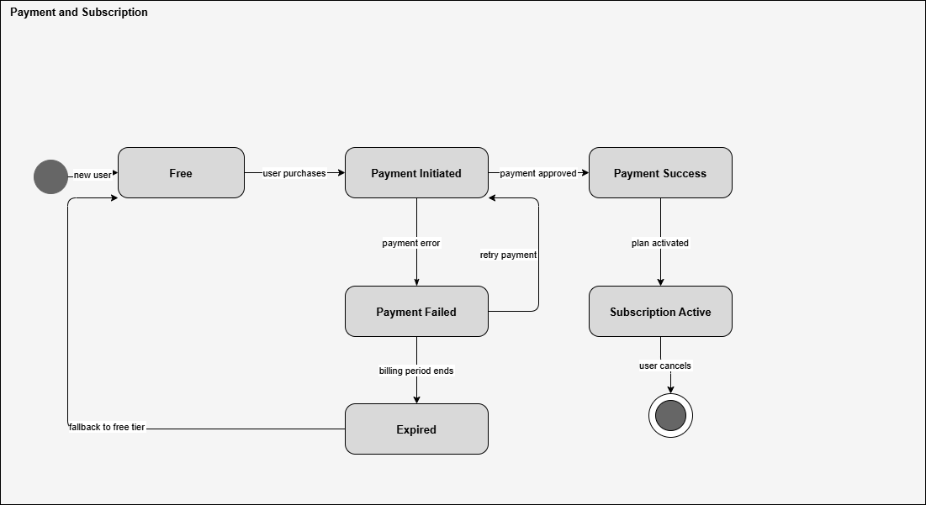
Figure 3.19 State Diagram for Payment and Subscription
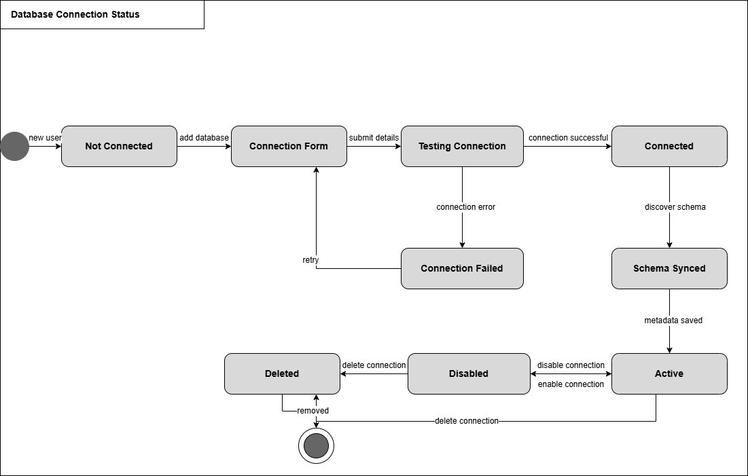

Figure 3.20 State Diagram for Database Connection

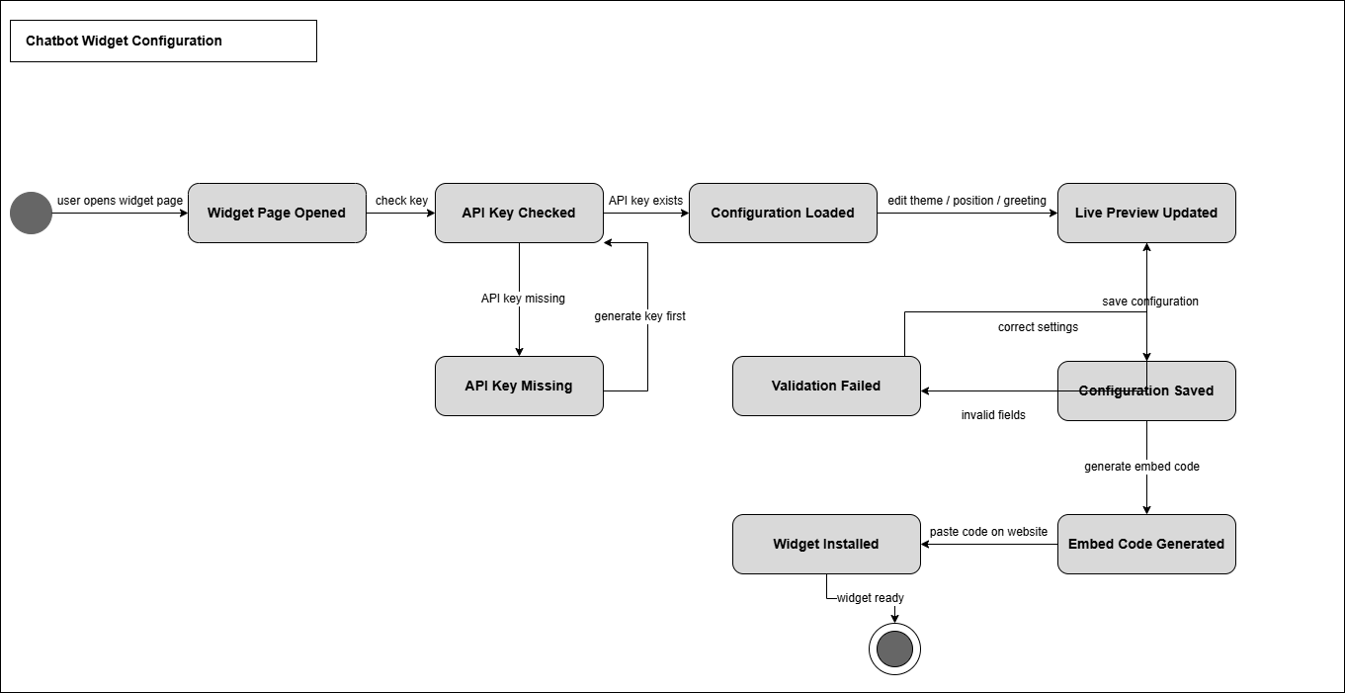
Figure 3.21 State Diagram for Chatbot Widget Configuration
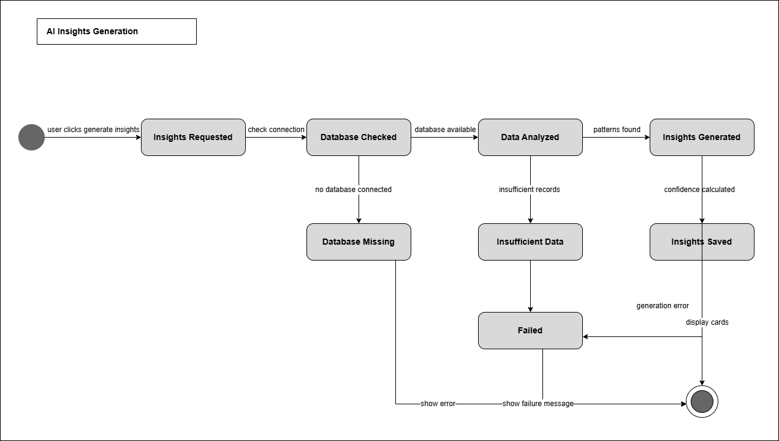

Figure 3.23 State Diagram for AI Query Processing

3.4.5 ERD DIAGRAM

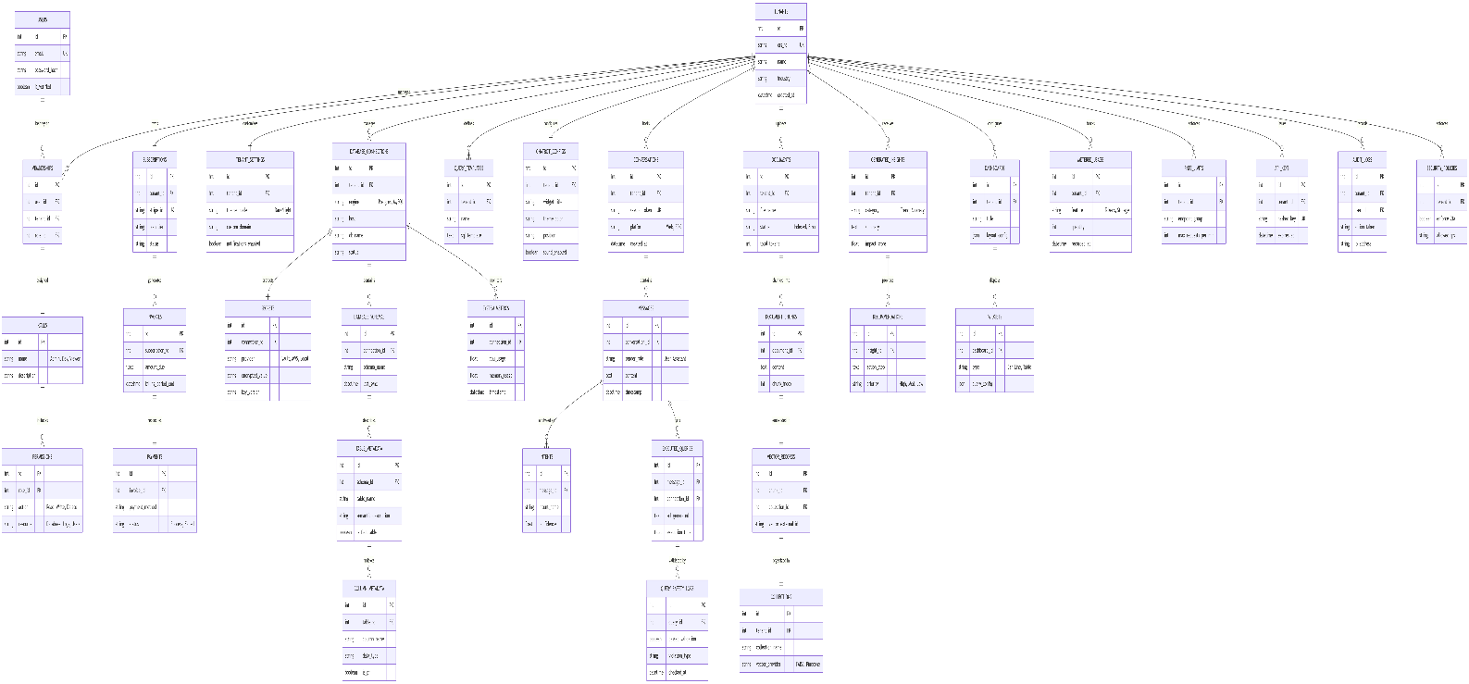

Chapter 4: Implementation

4.1 Project Methodology and Milestone Scope
DataSpeak AI is a conversational business intelligence platform that connects tenant-managed databases and business documents to a natural-language interface. The 60% implementation submission extends the original 30% foundation with an integrated conversation, schema and SQL-processing workflow. Users can manage a business workspace, connect a relational database, index documents and obtain source-supported answers through the dashboard or an embedded widget.
The project scope contains 20 named modules. This milestone covers the core implementation of 12 selected modules: 12 / 20 × 100 = 60%. Six modules are retained from the first milestone and six form the additional AI query workflow. This is a module-based submission boundary, not a claim that every planned feature, external integration or production-readiness requirement is complete. Supporting work outside the selected twelve is recorded separately and is not double-counted.
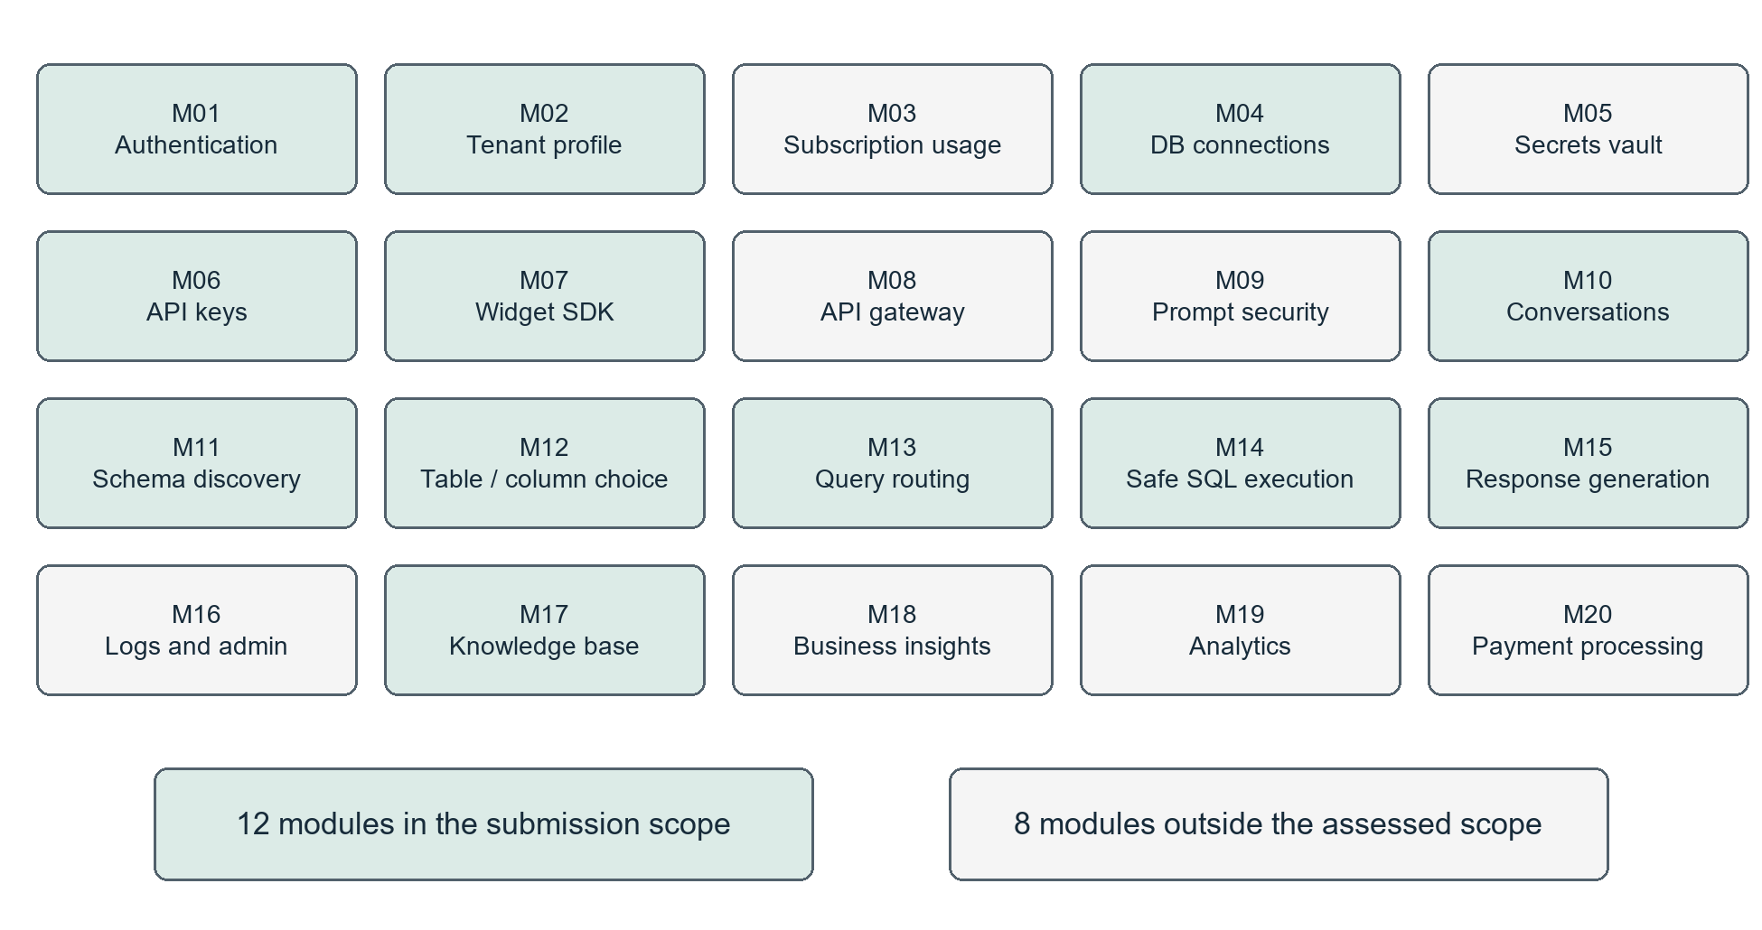
Figure 4.1 Module coverage for the 60% implementation submission
Development follows incremental implementation: define a user workflow, connect the React interface to validated FastAPI routes, persist tenant-scoped state, add the required AI or database service, and verify the behavior with focused tests. The original module numbering is retained throughout this chapter. [R1, R2]

4.1.1 Module Inventory and Coverage
Table 4.1 Original module inventory and milestone coverage, modules 1 to 10
ID | Module | 60% submission scope
M01 | User Authentication and Identity Management | Included: registration, email OTP, login, GitHub OAuth and password reset.
M02 | Tenant Onboarding and Profile Management | Included: tenant profile, members and invitation workflow.
M03 | Subscription, Billing and Usage Control | Outside assessed scope; usage-related support exists.
M04 | Database Connection and Credential Management | Included: connection management, connection checks and data preview.
M05 | Secrets Vault and Encryption | Outside separate module credit; credential encryption supports M04.
M06 | API Key Generation and Lifecycle Management | Included: internal keys and publishable widget-key lifecycle.
M07 | Chatbot Widget SDK and Frontend Integration | Included: configurable widget, secure session and streamed answers.
M08 | API Gateway, Request Validation and Rate Limiting | Outside separate module credit; endpoint and widget controls support this milestone.
M09 | Input Sanitization and Prompt Security | Outside separate module credit; SQL and input safeguards support M14.
M10 | Intent Detection and Conversation Management | Included: conversation persistence, route decisions and memory.

The first milestone comprised M01, M02, M04, M06, M07 and M17. The six additional modules selected for this submission are M10, M11, M12, M13, M14 and M15. The combined set forms a demonstrable path from tenant setup and data ingestion to conversational answers.

4.1.2 AI Module Coverage and Remaining Scope
Table 4.2 Original module inventory and milestone coverage, modules 11 to 20
ID | Module | 60% submission scope
M11 | Schema Discovery and Metadata Management | Included: persistent catalog, table/column metadata and relational ERD.
M12 | Intelligent Table and Column Selection | Included at baseline level: schema-guided LLM selection and identifier validation; no separately benchmarked schema-ranking model.
M13 | Query Routing and Template Selection | Included at baseline level: source preference, SQL/RAG/hybrid routing and prompt templates; a reusable query-template selection catalogue remains an extension.
M14 | Query Generation, Safety Validation and Execution | Included: SQL generation, read-only validation, bounded correction and limited execution.
M15 | Result Processing and Natural Language Response Generation | Included: tabular results, explanations, streaming and source metadata.
M16 | Logging, Monitoring and Admin Dashboard | Outside assessed scope; query logs and diagnostic services are supporting capabilities.
M17 | Knowledge Base and RAG Document Search | Included: extraction, hierarchical chunks, vector retrieval and citations.
M18 | AI Business Insights and Recommendations | Outside assessed scope; additional implementation exists in the repository.
M19 | Analytics and Visualization | Outside assessed scope; analytics code exists but receives no additional milestone credit.
M20 | Payment Processing and Subscription Billing | Outside assessed scope; payment-provider acceptance remains future work.

Module boundaries describe responsibilities rather than one screen per module. For example, a single chat request uses M10 to maintain context, M13 to choose an engine, M12 and M14 to generate a database answer, and M15 to present it. This dependency is why module counts must not be inferred from the number of dashboard pages.

4.2 Implemented Architecture and Technology Stack
The submitted implementation uses a React single-page dashboard and a modular FastAPI backend. Backend routers expose the application endpoints; service classes implement query routing, SQL execution, retrieval, generation and conversation memory. A Preact widget provides the embeddable client. The microservices, Qdrant and billing components shown in Chapter 3 describe the broader target design; FAISS and the current FastAPI service structure are the implemented choices.
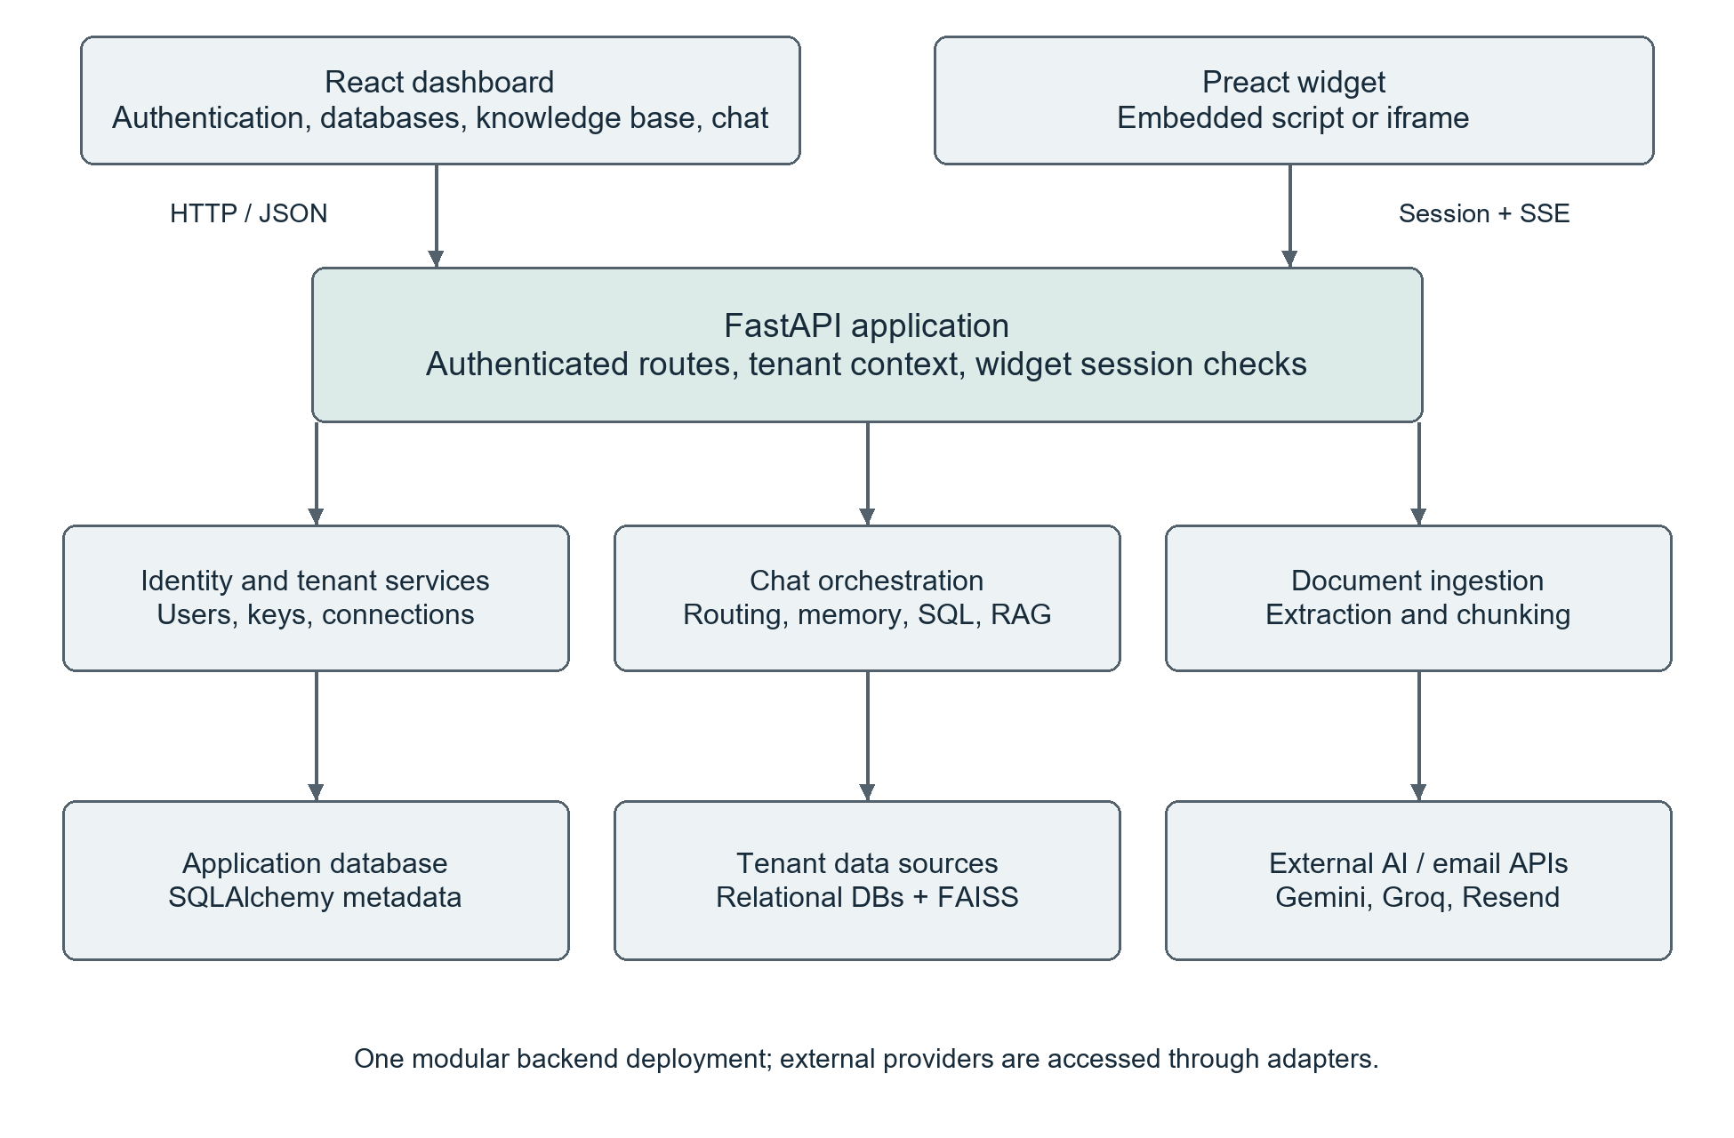
Figure 4.2 Implemented application architecture and principal interfaces
Table 4.3 Technology stack used by the selected modules
Layer | Implemented technologies | Role
Dashboard | React 18.3.1, TypeScript, Vite 6.3.5 | Protected navigation, forms, chat and results.
API and storage | FastAPI, Pydantic, SQLAlchemy; SQLite locally | Request validation and persistent application records.
Database access | SQLAlchemy adapters; PostgreSQL, MySQL/MariaDB, SQLite | Reflection, preview and read-only query execution.
AI and retrieval | LLM gateway, MiniLM embeddings, FAISS, sqlglot | Generation, retrieval and SQL validation.

4.2.1 Data Organization and Tenant Boundaries
The tenant is the principal ownership boundary. Users, database connections, documents, conversations and keys are associated with a tenant. Messages belong to a conversation. Document chunks belong to a document and may link to a parent chunk. Database schema records link a connection to persisted metadata used for query context and ERD rendering.
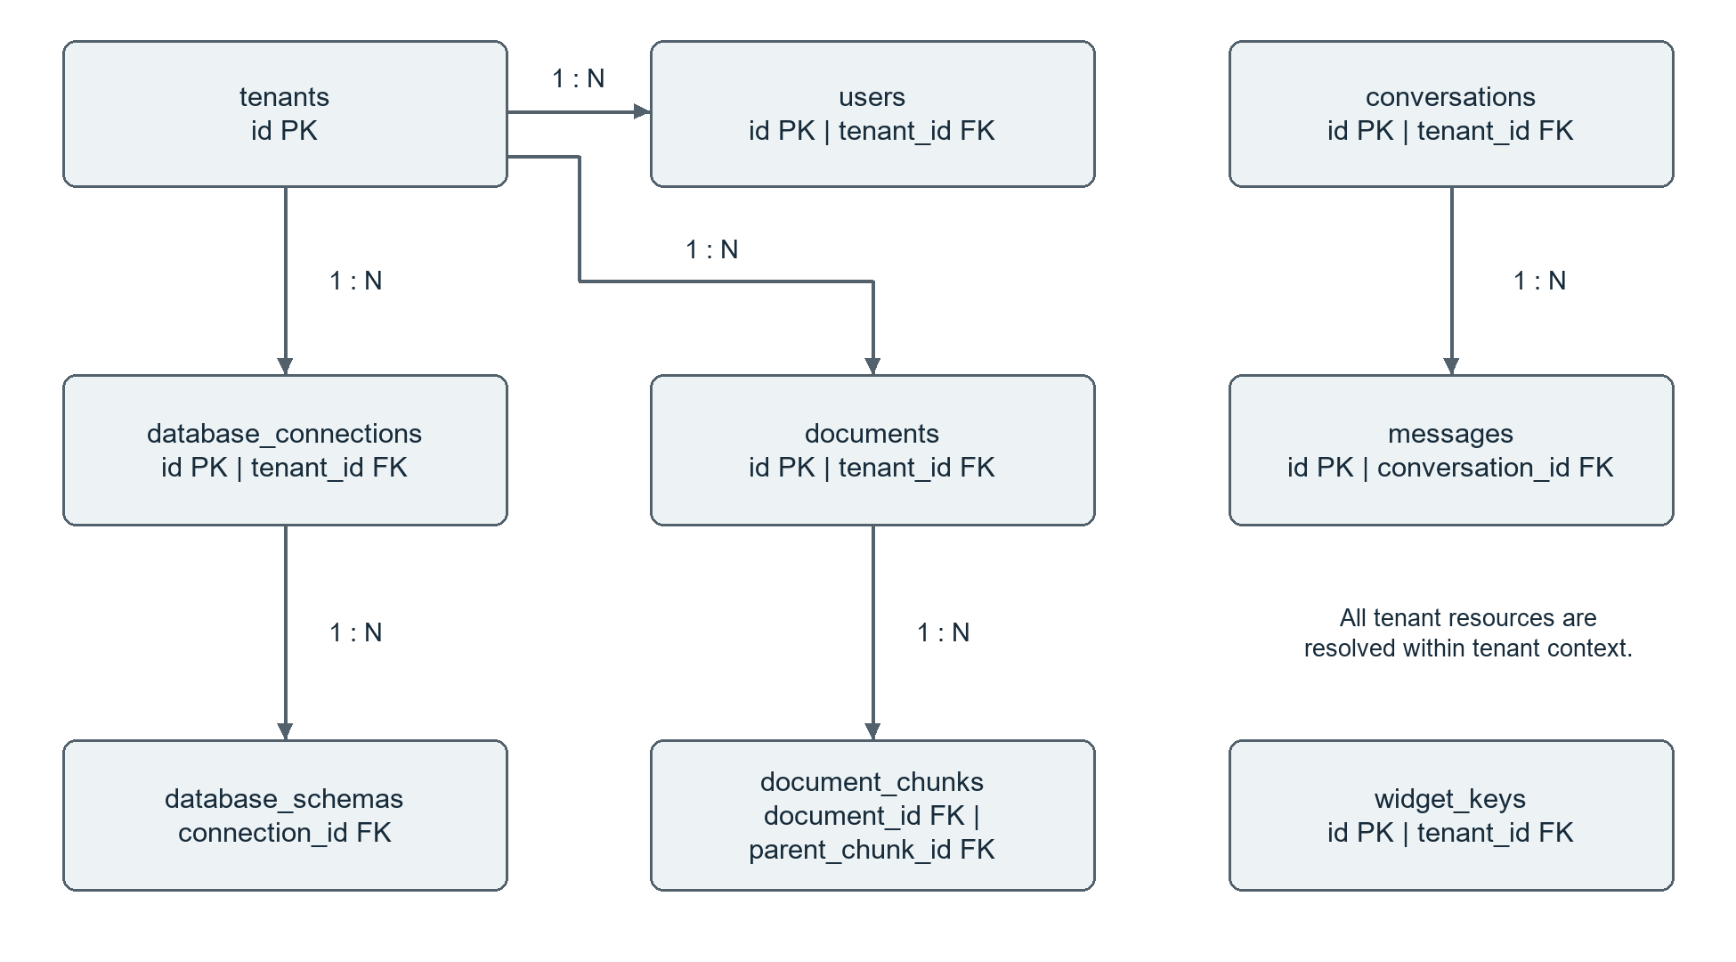
Figure 4.3 Core entity relationships used in the milestone
Figure 4.3 is a simplified implementation view. It shows selected one-to-many relationships; additional tenant links and the table/column metadata hierarchy are omitted for readability. External customer databases are separate from the application database. Document text and metadata are persisted in application tables, while vector indexes are isolated by tenant and embedding-model name.
The enterprise SQL specification remains the canonical design reference. The current ORM includes later additions beyond the original ten-model MVP, so the original MVP model count is not used as an implementation completion metric. A table existing in the model does not establish completion of its associated business workflow. [R3]
Implementation reference: backend/models.py; backend/database.py; docs/database/Full_Project_Schemas.sql

4.3 Implementation of Selected Modules

4.3.1 M01 User Authentication and Identity Management
Registration validates the request, rejects duplicate accounts, hashes the password with bcrypt and creates the user and tenant records required for onboarding. The user verifies ownership of the email account with a six-digit OTP. Login checks the stored password hash and verified status before issuing a signed JWT access token. GitHub OAuth is the social-login integration. Password recovery uses an expiring OTP and removes the used code after a successful reset.
The implemented authentication flow issues access tokens; a rotating refresh-token subsystem and Google sign-in are not part of this baseline. Email delivery depends on the configured email provider. Token lifetime is configuration-driven, and OTP expiration is checked on the server.

4.3.2 M02 Tenant Onboarding and Profile Management
A tenant represents the business workspace. The settings workflow reads and updates business details, lists workspace members and creates invitations with a role and optional database assignments. User and tenant identifiers are resolved through authenticated backend dependencies. These records provide the ownership context used by later database, document and chat operations.
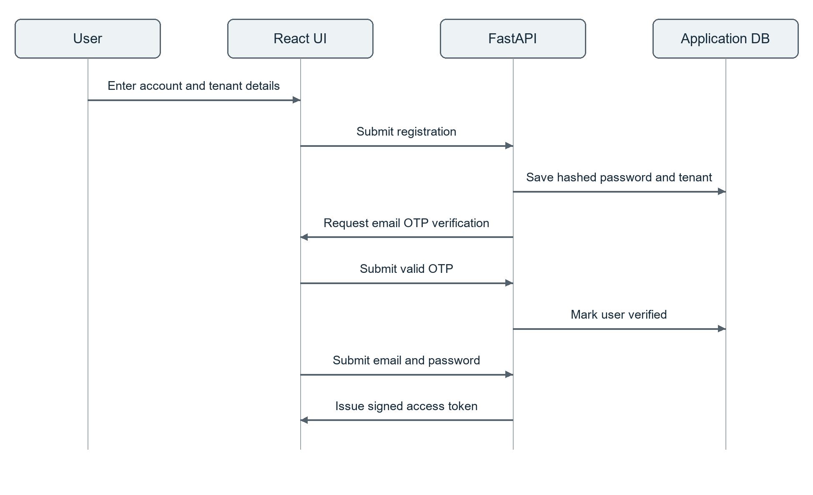
Figure 4.4 Registration, email verification and access-token sequence
Implementation reference: backend/routers/users.py; backend/routers/tenants.py; backend/auth.py; backend/dependencies.py

4.3.3 M04 Database Connection and Credential Management
The database-management interface collects the connection name, dialect and connection parameters. The backend supports creating, listing and deleting tenant connections, testing connectivity, inspecting tables and returning bounded previews. Credential protection is handled by the connection and cryptography helpers. Database passwords are not required in the answer-generation interface or in ERD responses.

4.3.4 M11 Schema Discovery and Metadata Management
The metadata catalog stores database schemas, tables, columns and relationships. The ERD endpoint reads the catalog first and performs live reflection on a cache miss or an explicit refresh. SQLAlchemy reflection gathers columns, primary keys and foreign-key constraints, including composite relationships. The frontend renders the graph with React Flow and a Dagre layout.
ERD access is tenant-scoped and restricted to relational engines. Host/path validation and a refresh cooldown constrain live introspection. Connection-specific field values and schema details supply context for later SQL generation. Unavailable databases and unsupported dialects must produce actionable errors during the demonstration; simulated fallback schema is not accepted as evidence of a live data-source connection.
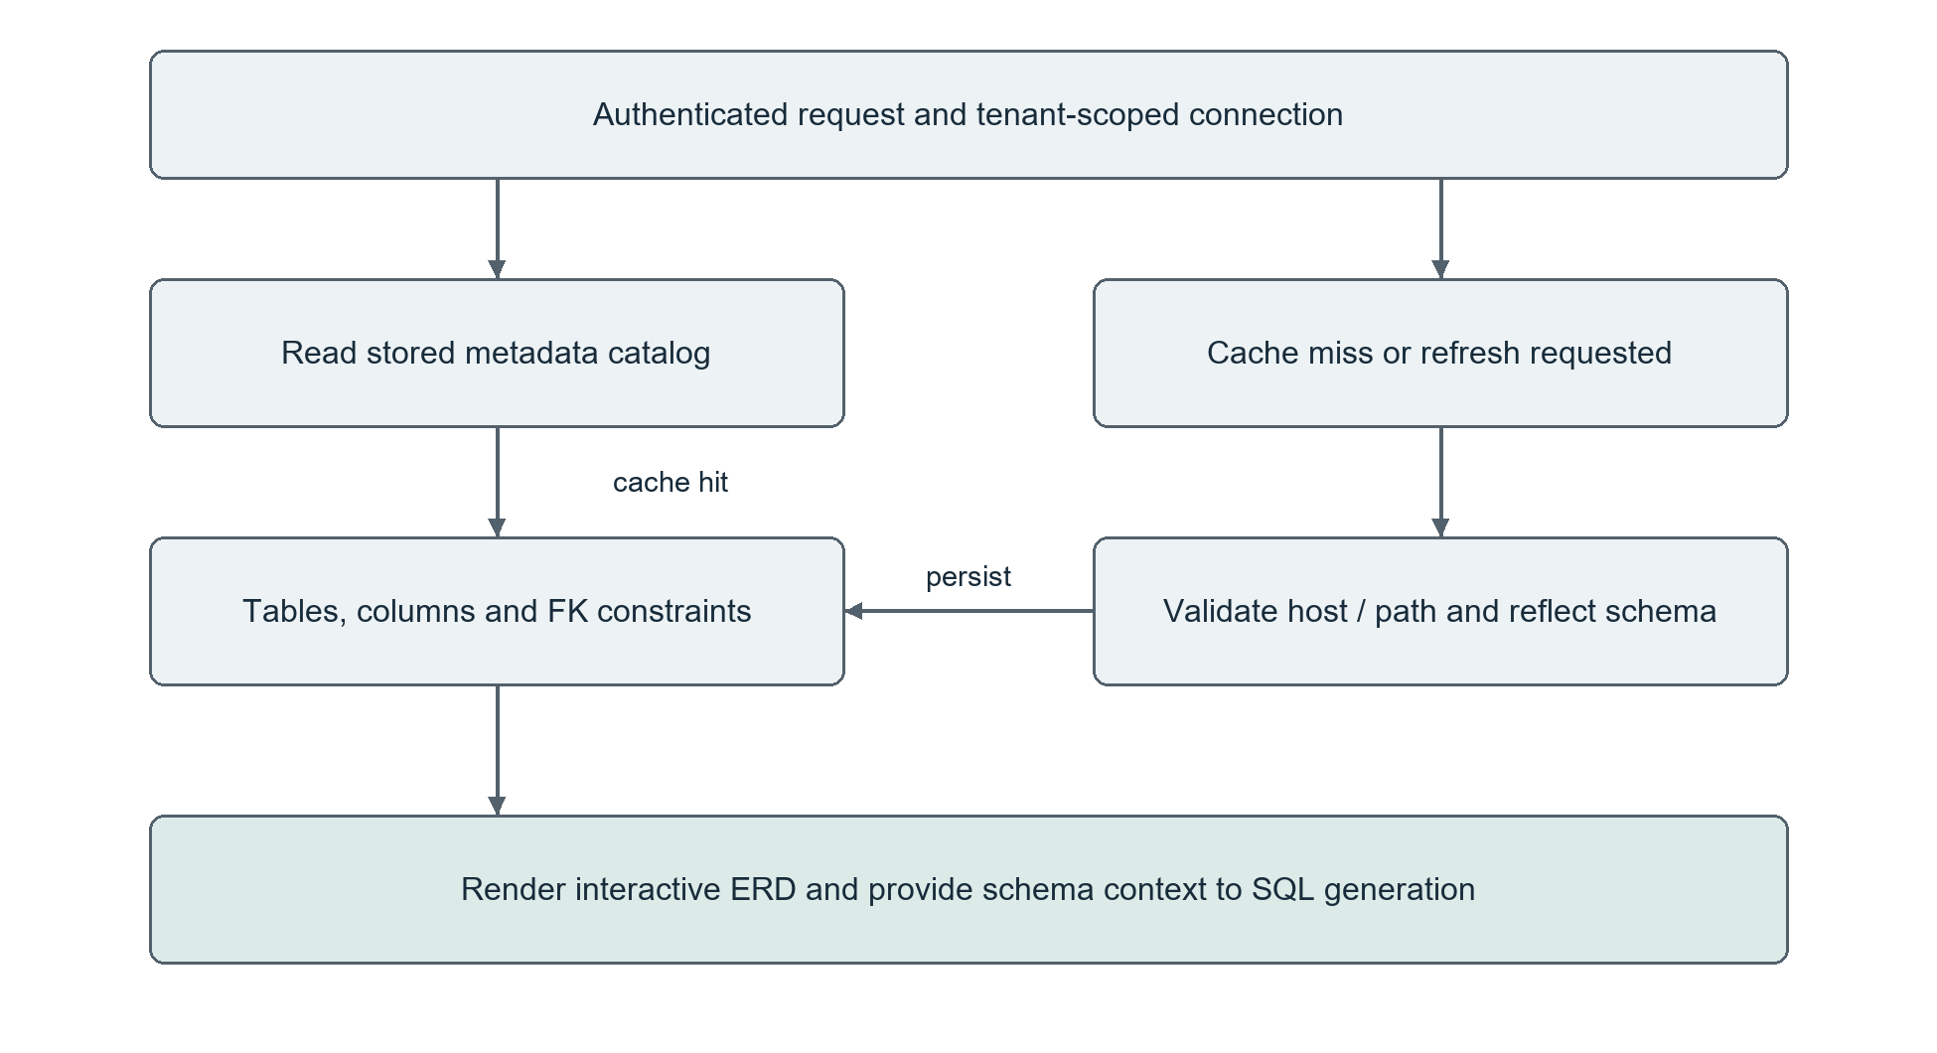
Figure 4.5 Catalog-first schema discovery and ERD workflow
Implementation reference: backend/routers/databases.py; backend/routers/erd.py; backend/services/erd_service.py; backend/services/sql_engine.py

4.3.5 M06 API Key Generation and Lifecycle Management
The key-management routes support creating, listing, revoking and deleting internal keys. Separate publishable widget keys use the pk_live_ prefix and provide allowed-origin settings, rotation and revocation. Tenant scoping prevents one business from managing another business’s keys. A publishable widget key identifies the integration; it is exchanged for a restricted session before chat.

4.3.6 M07 Chatbot Widget SDK and Frontend Integration
The widget can be embedded by script or iframe and configured through the dashboard. The browser requests a session using the publishable key and its origin. The backend checks the allowed origin and signs a session that contains the tenant context. The chat endpoint validates the session before retrieval or generation. Responses stream as server-sent events (SSE), with a final event carrying completion metadata.
The widget defaults to document retrieval. SQL access is explicitly enabled and bounded to permitted databases. Origin checks, per-key/IP/session limits and concurrent-stream limits protect the public integration. A disconnect releases the stream slot and avoids charging an incomplete response as a completed interaction.
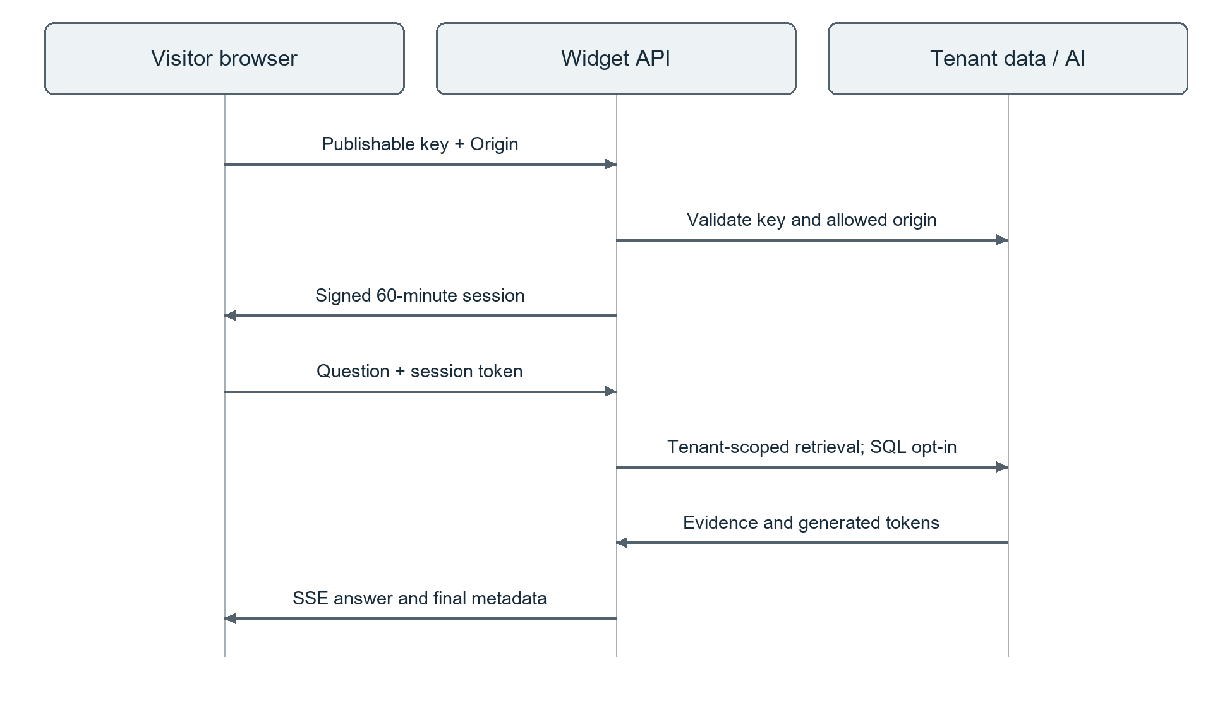
Figure 4.6 Widget session handshake and streamed response sequence
Implementation reference: backend/routers/api_keys.py; backend/routers/widget.py; backend/services/widget_session_service.py; src/widget/

4.3.7 M10 Intent Detection and Conversation Management
The conversational interface persists conversations and messages with their tenant, timestamps and response metadata. Users can list, retrieve, rename and delete conversations. The system records the selected retrieval route and preserves relevant source and SQL metadata with the answer, allowing a previous exchange to be reopened with context.
Conversation memory retains the most recent ten messages verbatim. When the history crosses the configured threshold of fifteen messages, older content can be summarized in a background task. Per-conversation locks and a monotonic summary counter prevent older background results from overwriting newer summaries. Failure falls back to a recent-message window. Initial titles use a short heuristic; later generated titles preserve a user’s manual rename.

4.3.8 M13 Query Routing and Template Selection
The query router first considers an explicit source preference: documents, database or automatic selection. In automatic mode it checks which data assets belong to the tenant. Connection names, table names and numerical/document-related keywords guide a fast decision; a configured LLM classifier can resolve ambiguous requests into SQL, RAG or hybrid processing. If classification is unavailable, deterministic heuristics provide a fallback.
Prompt templates define the input contract for classification, SQL generation and answer synthesis. This milestone implements route selection and these task-specific prompts. It does not claim completion of a separate query-template recommendation registry. Routing confidence describes the router decision; it must not be presented as the probability that the final business answer is correct.
Table 4.4 Query-routing behavior
Input state | Route behavior | Result
User selects documents | Prefer RAG retrieval | Answer from available tenant documents.
User selects database | Select specified or matching tenant database | Use schema-aware SQL processing.
Only one source type exists | Route to that available source type | Avoid selecting an unavailable data class.
Both source types exist | Use heuristics and optional classifier | Choose SQL, RAG or hybrid.
No usable source exists | Return an explanatory response | Do not treat missing data as business evidence.

Implementation reference: backend/services/query_router.py; backend/routers/chat.py; backend/services/conversation_memory.py; backend/services/conversation_title.py

4.3.9 M12 Intelligent Table and Column Selection
The SQL prompt receives the selected database’s schema context, including tables, columns, types, primary keys and foreign-key relationships. The language model selects identifiers relevant to the question. The SQL agent then validates referenced tables and columns against the known schema using sqlglot. This is a schema-guided baseline, rather than a separately trained or benchmarked ranking model. Current context construction may include the full schema, which limits scalability on very large databases.

4.3.10 M14 Query Generation, Safety Validation and Execution
The SQL agent generates a dialect-specific candidate and checks that it is a single read-only query. Invalid identifiers and execution errors feed a bounded correction loop of up to three attempts. A nested transaction dry-run is rolled back before the query is accepted. Successful candidates proceed to execution with row limits, engine-specific timeouts and a caller watchdog.
Unsafe operations are rejected immediately. Exhausted repairs return a failed status with an explicitly described fallback preview; that preview is not counted as a correct answer to the original question. Final answer correctness still depends on selecting the intended metrics and joins, even when the generated SQL is syntactically valid.
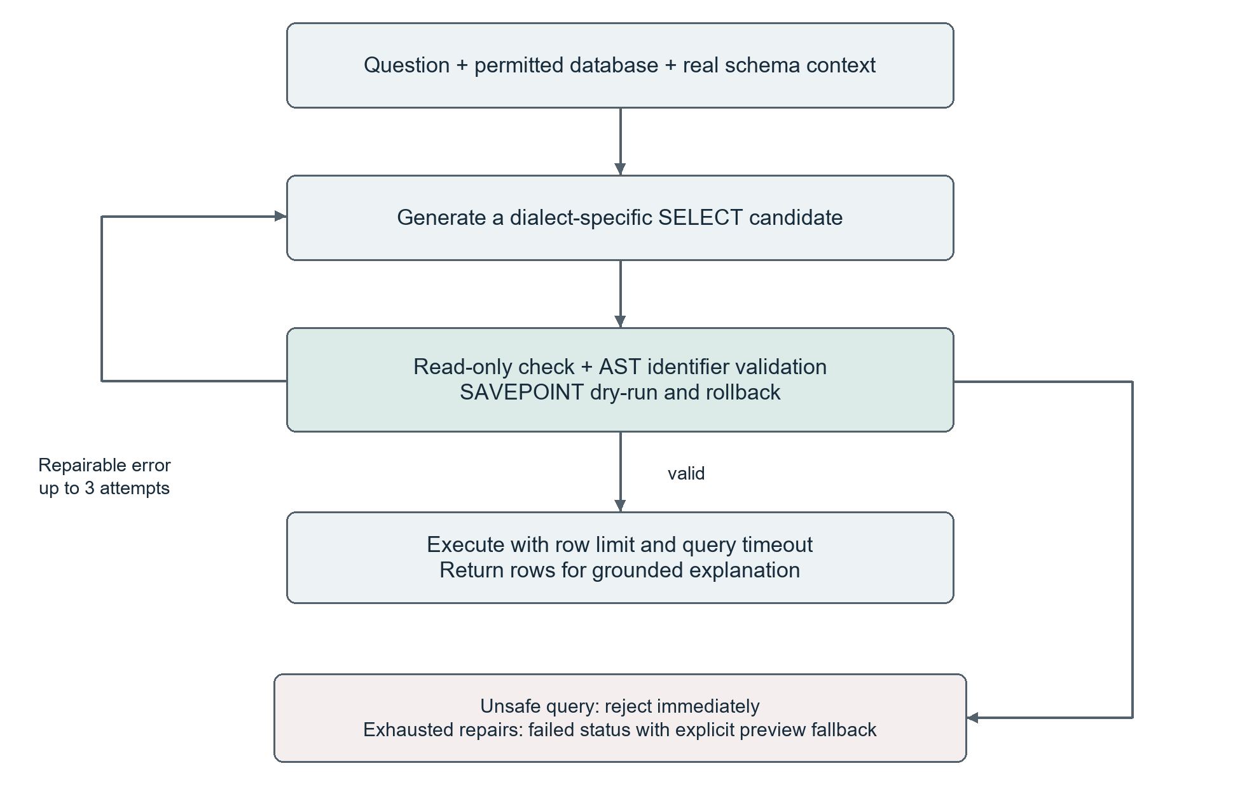
Figure 4.7 SQL generation, correction and execution controls
Implementation reference: backend/services/sql_agent.py; backend/services/sql_engine.py; backend/routers/chat.py

4.3.11 M15 Result Processing and Response Generation
SQL results are serialized as bounded row data and supplied to the explanation stage. RAG and hybrid answers use retrieved document evidence and, where applicable, database results. The generation gateway supports asynchronous output, provider-key rotation and retry/failover behavior. The shared streaming service emits real generation tokens rather than splitting a completed answer into artificial words.
The final SSE event carries metadata such as source citations, grounding results, SQL data and SQL-agent details. The dashboard renders result tables, citation cards and status indicators. Grounding compares claims with retrieved text and can display a low-confidence advisory; semantic similarity supports review but does not prove the truth of every claim.

4.3.12 M17 Knowledge Base and RAG Document Search
Document ingestion extracts narrative text, tables and available visual descriptions from supported formats. It stores parent sections and child chunks with source metadata, embeds child content using a pre-trained MiniLM model, and writes vectors into a tenant/model-specific FAISS index. A query uses the same embedding model. Dimension checks reject incompatible indexes, and retrieved child matches can expand to their parent context before answer generation.
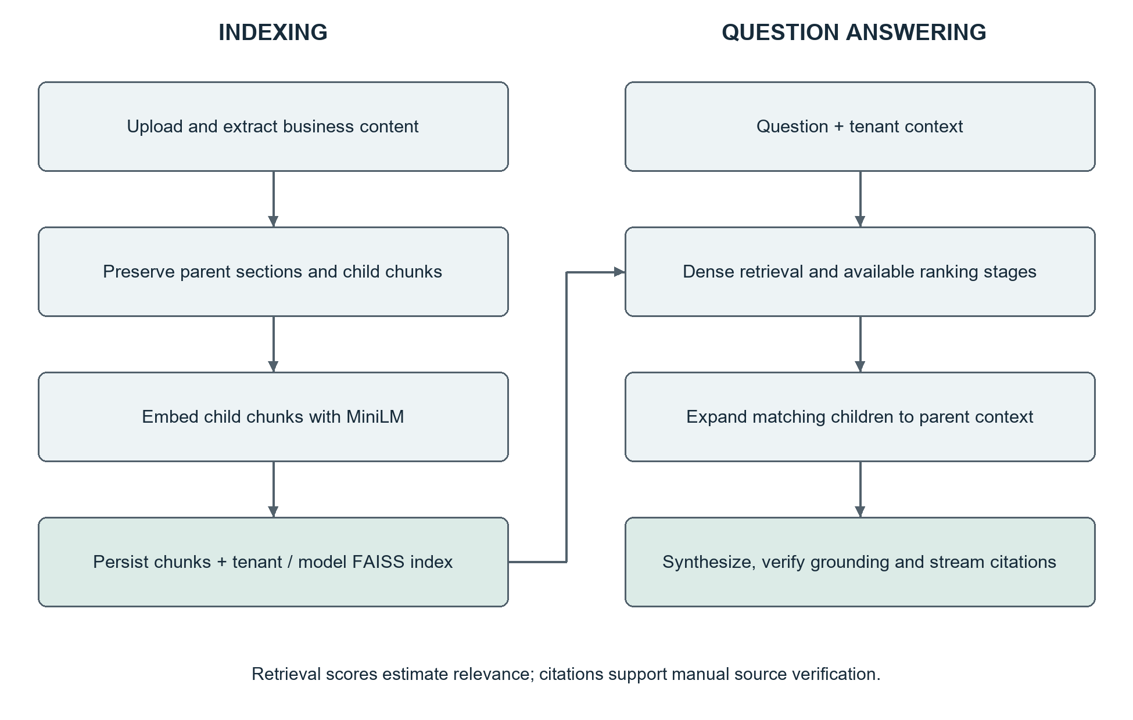
Figure 4.8 Document indexing and retrieval-augmented answer generation
Implementation reference: backend/routers/documents.py; backend/ingestion/semantic_chunker.py; backend/routers/chat.py; backend/services/citation_service.py

4.4 Algorithms and Data Processing

4.4.1 Collection, Extraction and Preprocessing
The relational path collects schema metadata and a limited read-only result set from an authorized database. The document path accepts an uploaded file, creates a processing record and extracts content using a format-specific adapter. PDFs can include text, tables and vision-assisted extraction; DOCX, spreadsheet, presentation, HTML/Markdown and text adapters are also present. The configured document upload endpoint enforces a 100 MB server-side limit. Format compatibility must be checked with representative files rather than assumed from the filename extension.
Extracted content retains document identity, page information and content type where available. Hierarchical chunking preserves larger parent sections and creates smaller searchable child chunks. The current upload defaults pass a target chunk size of 512 and an overlap of 50 to the chunker. These settings follow the implementation’s character-oriented splitting behavior; they are not a guaranteed word count or token budget.

4.4.2 Embeddings and Model Use
The default all-MiniLM-L6-v2 embedding model is pre-trained. This project performs embedding inference, retrieval and prompt-based generation; it does not train a new foundation model or report a training-accuracy score. Vector directories incorporate the tenant identifier and a sanitized model slug. Re-indexing is necessary when the stored vector dimensions do not match the selected embedding model.
Table 4.5 Document-processing stages
Stage | Input | Processing and output
Extraction | Business document | Format adapter produces text/table/visual content with metadata.
Chunking | Extracted content | Store parent context and overlapping child units.
Embedding | Child chunks | Create dense vectors and persist the tenant/model index.
Retrieval | Question and tenant | Find candidate chunks and build evidence context.
Synthesis | Evidence and question | Generate an answer with source and grounding metadata.

4.4.3 Principal Algorithms
The following steps describe the implemented control flow. They separate deterministic validation and data access from model-generated output so that the model cannot authorize a tenant, database or write operation.
Table 4.6 Principal algorithms used in the milestone
Algorithm | Main steps | Output
A1 Authentication | 1. Validate account input.  2. Verify password hash and email state.  3. Sign an access token.  4. Resolve later requests through the authenticated user. | Authenticated user and tenant context, or a validation error.
A2 Route selection | 1. Apply user source preference.  2. Inspect tenant assets.  3. Score source/schema keywords.  4. Use optional classifier.  5. Select SQL, RAG or hybrid. | Route type, confidence, explanation and optional database ID.
A3 SQL correction | 1. Load schema context.  2. Generate a candidate.  3. Check read-only form and identifiers.  4. Dry-run and roll back.  5. Retry repairable errors at most three times. | Validated candidate or explicit failed/fallback status.
A4 RAG response | 1. Embed the question.  2. Retrieve tenant-scoped matches.  3. Expand parent context.  4. Synthesize the answer.  5. Check grounding and attach citations. | Answer text, source references and confidence metadata.
A5 Streaming | 1. Begin generation.  2. Emit tokens in order.  3. Check disconnects.  4. Persist completed output.  5. Emit final metadata and release resources. | Incremental response and one terminal completion/error outcome.

No accuracy percentage is inferred from the existence of these algorithms. Chapter 5 evaluates their deterministic behavior with automated checks and defines a separate live evaluation for retrieval quality and SQL semantic correctness.

4.5 Security Techniques
Security controls are applied at authentication, resource selection, database execution and public-widget boundaries. Their presence is documented below at the implemented scope. The 60% milestone does not constitute an independent penetration test or a production security certification.
Table 4.7 Security controls and their verification focus
Boundary | Implemented control | Verification focus
Account access | bcrypt password hashing, signed access token, server-checked email/OTP state. | Reject bad credentials and expired or invalid verification codes.
Tenant resources | Resolve owner from authenticated context or verified widget-session claims. | Cross-tenant keys, conversations and ERD requests must not disclose data.
Connections | Credential encryption helpers; ERD host and SQLite path checks. | Verify stored-secret handling and reject disallowed live-reflection targets.
Generated SQL | Read-only checks, schema-aware AST validation, dry-run rollback, row caps and timeouts. | Reject writes/multiple statements and limit execution exposure.
Public widget | Allowed-origin handshake, HMAC session, key rotation/revocation and rate/stream limits. | Reject missing or unapproved origins and revoked keys.
Document retrieval | Tenant/model index partitioning, slug filtering and vector-dimension validation. | Prevent index mix-ups and handle incompatible embedding dimensions.
Streaming | Disconnect detection and cleanup in finalization paths. | Release stream slots on completion, cancellation and exceptions.
Diagnostics | Admin dependency on the LLM metrics route. | Verify 401 for anonymous and 403 for unauthorized users.

Production hardening remains necessary: restrict deployment CORS settings, remove or gate development administrator seeding, require managed secrets and HTTPS, and verify authorization consistently on every resource route. These deployment activities are not credited as complete merely because development tests pass.

4.6 External APIs and Software Libraries
Table 4.8 External integrations and principal SDKs
API or library | Purpose | Integration conditions
Gemini API | Language generation and available vision-assisted document analysis. | Provider key and model are configuration-driven; availability and quota affect live requests.
Groq API | Alternative generation provider through the gateway. | Used where configured; fallback behavior is tested with controlled provider doubles.
GitHub OAuth | Account sign-in through GitHub authorization. | Client configuration and a valid redirect/callback are required for live acceptance.
Resend / SMTP | Send verification and password-reset codes. | Live delivery depends on sender configuration and provider availability.
SentenceTransformers / HuggingFace | Pre-trained MiniLM embeddings. | Model files must be available; indexing and querying must use compatible dimensions.
FAISS | Local semantic vector search. | Indexes are partitioned by tenant/model and require consistent persistence.
SQLAlchemy and sqlglot | Database access/reflection and SQL syntax-tree validation. | Dialect support requires corresponding drivers and representative integration tests.
React Flow and Dagre | Interactive relational schema visualization. | The graph is derived from authorized metadata; layout state is a frontend concern.

The dependency manifest is the source of installed frontend versions, and the backend requirements specify the Python dependencies. Provider model names are environment-controlled and should be recorded with any reproducible live evaluation. Stripe, a Qdrant service and a separate LangGraph deployment are not required to demonstrate the selected baseline.
Implementation reference: package.json; backend/requirements.txt; backend/services/llm_generation_service.py; backend/routers/users.py

4.7 User Interface and Demonstration Workflow
The dashboard places configuration and analysis workflows within a protected layout. The retained interface examples below illustrate the project’s existing screens; screenshots are visual evidence of interface structure, not proof that a new test was executed. Test outcomes are recorded separately in Chapter 5.
Table 4.9 Interface-to-module mapping
Interface | Selected modules | Demonstration action
Account and verification pages | M01, M02 | Register a workspace, verify the account and sign in.
Business settings and invitations | M02 | Update a profile and inspect workspace membership.
Database management and ERD | M04, M11 | Connect a sample source, inspect schema and view a bounded preview.
Key and widget settings | M06, M07 | Create a publishable key, allow a test origin and configure the widget.
Conversational workspace | M10, M12–M15 | Ask a database question, inspect the query/result and continue the conversation.
Upload and knowledge base | M17, M15 | Index a business document and ask a source-supported question.

A suitable demonstration uses a small synthetic business database with known totals and a short business-policy document with known answers. An examiner can then compare the displayed SQL and rows to the expected total, open a document citation, and test denial of an unauthorized widget origin. This makes the demonstration reproducible without exposing real customer data.

4.7.1 Account and Database Connection Interfaces
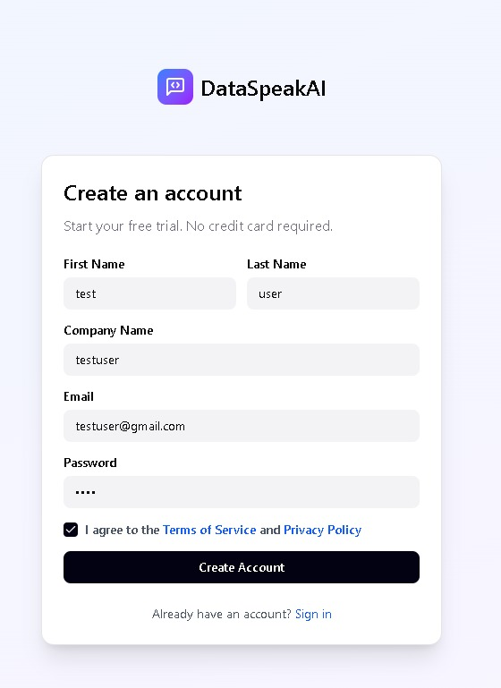
Figure 4.9 Existing DataSpeak AI account-registration interface
The registration screen collects user and company details before the verification workflow. Server-side validation and verification state determine whether the account may subsequently log in.
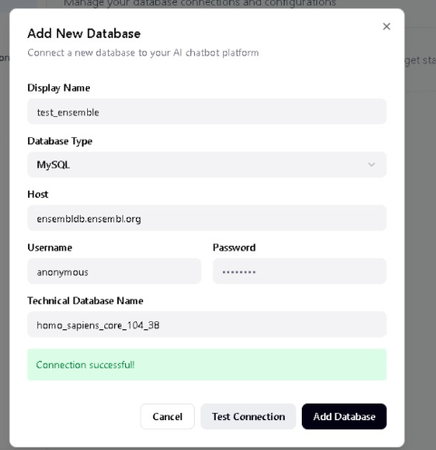
Figure 4.10 Existing database connection and connectivity-check interface

4.7.2 Knowledge Base and Database Preview Interfaces
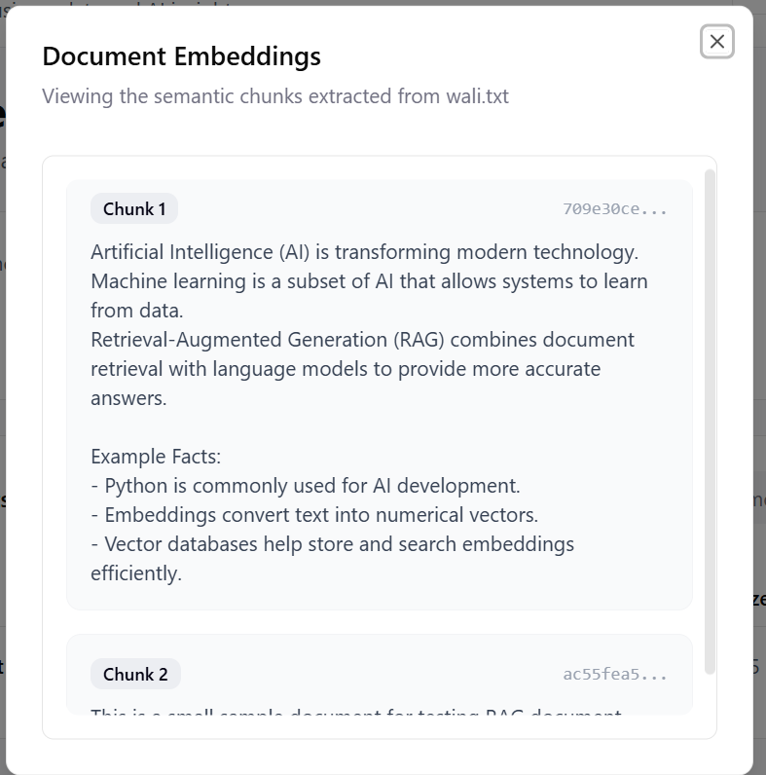
Figure 4.11 Existing knowledge-base chunk inspection interface
Chunk inspection exposes the extracted text used for retrieval. The hierarchy and source metadata described in Section 4.4 extend this inspection workflow by preserving section and page context.
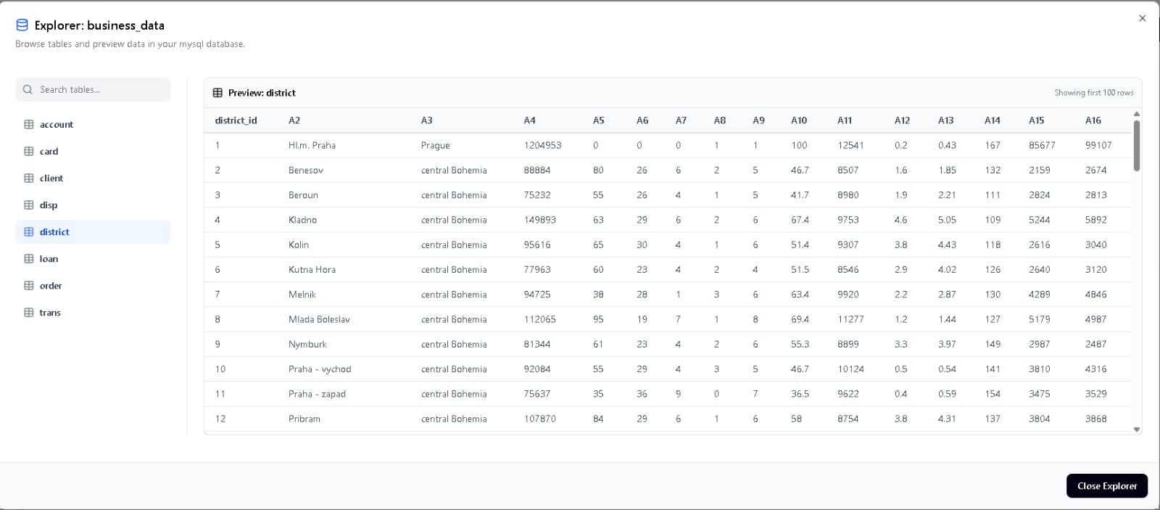
Figure 4.12 Existing database explorer and table-preview interface
A preview confirms that a permitted source can return real rows. It should be checked against the selected database and compared with the query result used during the live demonstration.

4.8 Deployment Configuration and Milestone Limitations
The development arrangement runs the Vite frontend and the Uvicorn/FastAPI backend as separate processes. The frontend reads VITE_API_BASE_URL. The backend reads application database, authentication, provider and widget settings from environment variables. Document processing uses FastAPI background tasks by default and can use a Celery worker when a broker is configured.
Table 4.10 Demonstration deployment checks
Configuration area | Required verification before demonstration
Frontend/API connection | Confirm the dashboard uses the intended backend URL and protected routes return authenticated responses.
Application database | Use a backed-up development database or an isolated demonstration database with known tenants.
AI and embeddings | Confirm the embedding model is available and provider keys work without exposing them in screenshots or logs.
Document storage | Verify write access to upload/vector storage and persistence after a restart.
Public widget | Serve from an explicitly allowed origin and verify rejection from another origin.
External integrations | Exercise GitHub OAuth and email delivery with the actual configured services.

The milestone has four principal limits. First, table/column choice is schema-guided and has not been benchmarked as an independent ranking model. Second, external service delivery and real cross-dialect operation need live acceptance evidence. Third, a fallback preview or simulated schema must remain distinguishable from a verified answer. Fourth, subscription/payment flows, broader administration and analytics assessment remain outside the selected twelve-module submission.
The implemented baseline demonstrates an integrated data-to-answer workflow. Further work should address the acceptance gaps in Chapter 5 and complete the remaining module scope before a final production release.

Chapter 5: Testing and Evaluation

5.1 Evaluation Approach and Test Environment
Testing evaluates the selected 60% implementation through unit, functional, business-rule and integration checks. The automated evidence in this chapter was collected on 17 October 2026 from the project workspace. The frontend production build and existing Vitest suites were run, followed by a focused selection of backend Pytest suites. The selection targets widget security, schema discovery, streaming, conversation state, SQL correction and document-grounding controls.
Backend checks use isolated SQLite data and test doubles where defined by the existing suites. Provider doubles allow deterministic checks of failures and token delivery without relying on a paid API response. Endpoint tests also exercise FastAPI application initialization and request handling. They do not establish live email delivery, GitHub authorization, real provider quality or production load capacity.
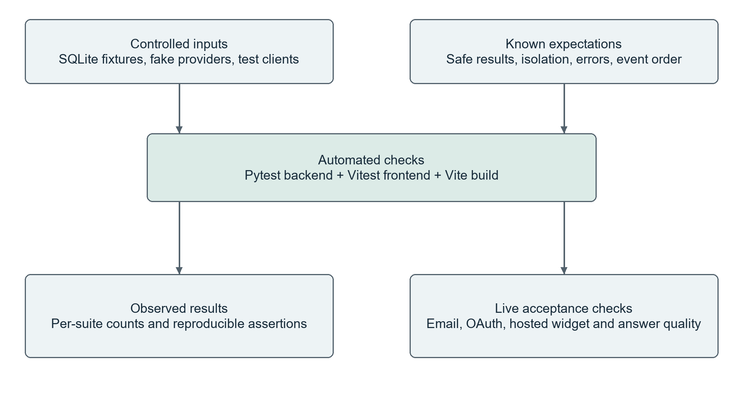
Figure 5.1 Test inputs, automated verification and live acceptance boundary
Table 5.1 Observed verification summary
Check | Observed outcome | Scope
Vite production build | Passed | 2,905 modules transformed; build completed in 49.32 seconds. A bundle-size warning remains.
Frontend automated tests | 20 passed in 2 files | 11 SSE-parser cases and 9 ERD transformation/layout cases.
Focused backend tests | 80 passed; 0 failed/error; 80 collected | Selected existing suites only; see Table 5.2.

5.1.1 Backend Suite Results and Evidence Limits
Table 5.2 Focused backend results grouped by suite
Suite coverage | Tests | Passed | Result
Widget keys, sessions and tenant/origin rules | 12 | 12 | Passed
Catalog-first ERD, metadata and connection validation | 16 | 16 | Passed
SSE order, completion, disconnect and cleanup | 9 | 9 | Passed
Conversation memory and summary consistency | 6 | 6 | Passed
Background titles and preservation of manual names | 5 | 5 | Passed
SQL identifiers, correction and rollback dry-runs | 8 | 8 | Passed
Parent/child document chunking | 4 | 4 | Passed
Claim grounding and citation attributes | 4 | 4 | Passed
Tenant/model vector paths and dimensions | 4 | 4 | Passed
Gateway behavior, telemetry and execution safeguards | 12 | 12 | Passed

A passing test means its defined assertion succeeded in the controlled test environment. The backend and frontend counts are separate executions and should not be added to historical changelog totals. The older changelog contains previous verification records; those totals are not represented as a new full-regression run in this submission.
Test data is synthetic or fixture-based. SQL-agent tests create small temporary SQLite tables. Widget tests create two isolated tenants and verified users. LLM gateway and streaming tests use controlled responses to verify event order and failure paths. PostgreSQL/MySQL inspector tests use mocked inspectors; they do not replace tests against running database servers.
Reproduction: use the existing test files listed in Section 5.7 with EMBEDDING_WARMUP disabled and an isolated DATABASE_URL, then run the existing frontend test and build scripts. Keep provider credentials out of published reports and do not run fixtures against a live customer database.

5.2 Unit Testing
Unit tests isolate deterministic behavior in the SQL, retrieval and conversation services. The following cases link the intended condition to an actual automated test result; a pass is recorded only when that named test appears in the current test report.
Table 5.3 SQL-agent unit and behavioral cases
ID | Test case and input | Expected behavior | Actual
UT01 | Known table and columns  SELECT against the fixture schema | Identifiers accepted | Passed
UT02 | Unknown table  Reference to a missing table | Validation rejects the table | Passed
UT03 | Unknown column  Reference to a missing column | Validation rejects the column | Passed
UT04 | Valid dry-run  Valid read-only query in SQLite | Dry-run succeeds and rolls back | Passed
UT05 | Invalid SQL syntax  Malformed statement | Execution error is captured | Passed
UT06 | Repairable SQL error  First candidate invalid; second valid | Agent succeeds after correction | Passed
UT07 | Unsafe statement  Multiple statements or DDL | Unsafe operation is blocked | Passed
UT08 | Repair limit  Repeated invalid candidates | Failed status and explicit fallback | Passed

These tests establish identifier handling and bounded correction under controlled conditions. They do not measure whether generated SQL expresses the correct business interpretation for an arbitrary natural-language question.

5.2.1 Streaming and Gateway Unit Tests
Table 5.4 Streaming, provider and execution-unit cases
ID | Controlled condition | Expected behavior | Actual
UT09 | Tokens emitted in known order | SSE content preserves order and frame format | Passed
UT10 | Provider still generating | First token is delivered before final completion | Passed
UT11 | Client disconnect | Stream slot is reclaimed | Passed
UT12 | User cancels answer | Monthly completed-answer cap is not incremented | Passed
UT13 | Partial upstream failure | Client receives a sanitized error event | Passed
UT14 | Gateway receives HTTP 429 | Next configured candidate is attempted | Passed
UT15 | Slow database connection | Caller watchdog limits waiting time | Passed
UT16 | SQLite query execution | Read-only/timeout controls are applied | Passed

Additional selected suites verify document hierarchy, citation-grounding fields, model-specific vector paths, memory updates and title generation. Their aggregate counts are reported in Table 5.2. No live-provider response-time benchmark is inferred from the timing of a mocked streaming test.

5.2.2 Frontend Unit Verification
The existing frontend suite passed all twenty tests. Eleven cases cover the widget SSE parser; nine cover ERD transformations and layout. This supports correct parsing and graph preparation at function level. It does not represent a browser-based acceptance test of all dashboard screens or all supported devices.

5.3 Functional Testing
Functional acceptance checks evaluate complete user workflows through the interface or API. The following cases are defined for the submission demonstration. They were not executed as live end-to-end acceptance tests during this verification run, so their status remains Not run rather than an assumed Pass.
Table 5.5 Live functional acceptance cases for identity, data access and widget setup
ID / modules | Steps and test data | Expected result | Status
FT01  M01, M02 | Register a fresh synthetic user and business; enter the received email OTP; sign in. | Workspace is created, email is verified and the protected dashboard opens. | Not run
FT02  M01 | Use wrong credentials, an unverified account and an expired OTP. | The appropriate validation error appears and no authenticated session is issued. | Not run
FT03  M01 | Complete GitHub authorization using the configured callback. | The GitHub account maps to the intended application user. | Not run
FT04  M02 | Update business details; invite a second user and inspect membership. | Details persist and the invited user receives the intended role and access. | Not run
FT05  M04, M11 | Connect a sample relational database; inspect tables and ERD; refresh once. | Real schema/rows appear; refresh controls are enforced. | Not run
FT06  M06, M07 | Create a widget key, configure one allowed origin and open the widget there. | Session is issued; configured appearance and chat work. | Not run

Acceptance evidence should record the environment, input, expected output, observed output and screenshot or request identifier. A screenshot from an earlier development stage cannot by itself close one of these live test cases.

5.3.1 Conversational and Document Functional Tests
Table 5.6 Live functional acceptance cases for chat, SQL and RAG
ID / modules | Steps and test data | Expected result | Status
FT07  M07 | Load the same widget from an unapproved origin; then revoke its key. | New unauthorized sessions are rejected and revocation is respected. | Not run
FT08  M10, M13 | Start a conversation, ask a follow-up, rename it and reopen it. | Context and stored history persist; manual title is preserved. | Not run
FT09  M12, M14 | Ask a known sales-total question over a small fixture dataset. | SQL references real tables and returns the independently calculated total. | Not run
FT10  M14 | Request a destructive operation and an excessively broad result. | Writes are rejected and result-size/time limits remain effective. | Not run
FT11  M17, M15 | Upload a short policy PDF, wait for indexing and ask a question with a known answer. | Answer uses the uploaded evidence and opens a relevant citation. | Not run
FT12  M10, M15 | Start a streamed answer, stop it, and ask another question. | UI stops cleanly; resources are released and a new request can proceed. | Not run

For FT09, compare both the generated SQL and its result with a manually verified query. For FT11, assess whether the cited passage actually supports the answer. These two checks distinguish syntactic validity from business correctness and source relevance from claim support.

5.4 Business Rules Testing

5.4.1 Widget Session Decision Table
Widget-session issuance depends on the key, request origin and security policy. Y means true, N means false and a dash means that the condition is irrelevant after an earlier rejection.
Table 5.7 Widget handshake decision rules
Condition / action | R1 | R2 | R3 | R4 | R5
Publishable key exists and is active | Y | N | Y | Y | Y
Origin or acceptable Referer is present | Y | – | N | Y | Y
Allowed-origin list is non-empty | Y | – | – | N | Y
Origin matches the allowlist | Y | – | – | – | N
Issue a signed session | Y | N | N | N | N
Reject session request | N | Y | Y | Y | Y

Table 5.8 Executed widget business-rule cases
ID | Condition | Expected behavior | Actual
BR01 | Allowed origin and active key | Session issued | Passed
BR02 | Unauthorized origin | Request rejected | Passed
BR03 | No Origin and no Referer | Request rejected | Passed
BR04 | Revoked key | Request rejected | Passed
BR05 | Empty origin allowlist | Deny all session creation | Passed

5.4.2 SQL and Tenant Access Rules
Table 5.9 SQL candidate validation decision rules
Condition / outcome | R1 | R2 | R3 | R4
Statement is single and read-only | Y | N | Y | Y
Identifiers are in the known schema | Y | – | N | Y
Dry-run succeeds | Y | – | – | N
Accept candidate for bounded execution | Y | N | N | N
Reject immediately as unsafe | N | Y | N | N
Attempt correction within limit | N | N | Y | Y

When correction attempts are exhausted, the agent returns a failed status and explicitly identifies any fallback preview. A fallback is excluded from the semantic-success count for the original question. Separately, resource authorization must be checked before schema retrieval or execution, regardless of the validity of the SQL text.
Table 5.10 Executed tenant and schema business-rule cases
ID | Condition | Expected behavior | Actual
BR06 | Another tenant’s widget key | No cross-tenant key access | Passed
BR07 | Another tenant’s ERD or anonymous request | 404/401 as asserted by the endpoint test | Passed
BR08 | Too-frequent schema refresh | 429 with retry guidance | Passed
BR09 | Unsupported relational-ERD dialect | 400 response | Passed
BR10 | ERD response contents | No credentials or connection-string leak | Passed

5.5 Integration Testing
Integration tests verify the boundaries between API routes, service logic, stored state and response serialization. The selected backend suites use FastAPI TestClient, SQLAlchemy fixtures, temporary SQLite databases and provider doubles. Their scope is wider than a pure function test but narrower than a deployed production system.
Table 5.11 Executed integration scenarios
ID | Integration boundary | Expected result | Actual
IT01 | Widget-key routes + application database | Create, update, rotate/revoke and delete according to key lifecycle rules | Passed
IT02 | Session API + tenant conversations | Keep conversation/session records isolated by tenant | Passed
IT03 | ERD route + metadata catalog | Use persisted catalog and bypass it on explicit refresh | Passed
IT04 | SQLite schema + ERD response | Reflect expected tables, columns and relationship features | Passed
IT05 | Dashboard/widget + stream service | Both chat entry points use the shared streaming service | Passed
IT06 | Metrics route + authorization | Apply administrator access checks and serialize metrics | Passed

Live integration work still includes GitHub OAuth, email-provider delivery, a hosted widget origin, actual PostgreSQL/MySQL servers and live answer generation. Browser-level testing should also verify that final SSE metadata appears alongside the corresponding message without a race or stale state.

5.6 Evaluation Findings and Remaining Work
The current evidence confirms a successful frontend production build, twenty passing frontend tests and 80 passing cases in the selected backend run. This supports the tested parsing, schema, widget, streaming and SQL-control behaviors. It does not establish a 100% full-project pass rate, a measured production availability level or an end-to-end answer-accuracy percentage.
Table 5.12 Evaluation evidence and remaining acceptance work
Evaluation dimension | Current evidence | Next acceptance measure
Build and interface logic | Production build and 20 frontend tests passed. | Complete the browser-level functional cases in Tables 5.5–5.6.
Isolation and guardrails | Selected widget, ERD and SQL assertions executed. | Broaden negative tests across all protected routes and real database engines.
SQL semantic accuracy | Controlled schema and correction tests executed. | Use a labeled question set; score result equality against verified SQL.
Retrieval and grounding | Chunking, citation and vector-isolation suites executed. | Measure relevant-source retrieval and human-checked claim support.
Performance and resilience | Controlled streaming and timeout behavior executed. | Measure live p50/p95 latency, time to first token and cancellation under load.
Deployment readiness | Local build and API tests are available. | Complete secrets, CORS, seeding, TLS and external-provider acceptance.

The frontend build reported a large-bundle warning. The backend run reported 70 warnings, including dependency deprecations and HMAC key-length warnings in the test configuration. These did not fail the checks; dependency updates, appropriately sized managed secrets and bundle optimization remain deployment work. Existing simulated-schema or fallback-preview paths also require explicit handling so a failed source connection is not mistaken for successful business analysis.
The 60% submission therefore presents twelve selected module baselines with an integrated architecture and reproducible automated evidence. The next milestone should close the live functional cases, deepen schema selection and query-template behavior, and assess the remaining billing, administration, insights and analytics scope.

5.7 Implementation and Test References
The following project sources establish the module inventory, implementation details and test coverage used in Chapters 4 and 5. Paths are relative to the DataSpeakAI project root. Source files provide implementation evidence; the named test suites provide reproducible verification of the specific behaviors described in this chapter.
Table 5.13 Traceability to project sources and verification suites
Ref. | Project source | Use
[R1] | docs/architecture/fyp_phase1_plan.md | Original 20-module scope and six-module 30% milestone.
[R2] | docs/reports/mockup_analysis.md | Original module names and distinction between UI and engine modules.
[R3] | backend/models.py; docs/database/Full_Project_Schemas.sql | Implemented persistence models and canonical enterprise design.
[R4] | docs/architecture/conversational_retrieval_architecture.md | Conversation, SQL, RAG and hybrid design context.
[R5] | backend/routers/; backend/services/; backend/ingestion/ | Current implementation referenced beside each module description.
[R6] | tests/test_phase2_widget_keys_sessions.py; tests/test_phase5_erd_backend.py | Widget lifecycle/security and relational ERD tests.
[R7] | tests/test_phase7_1_2_streaming_backend.py; test_phase7_1_4_memory.py; test_phase7_1_5_titles.py (in tests/) | Streaming, memory and title verification.
[R8] | tests/test_phase7_2_1_sql_agent.py; test_phase7_2_2_hierarchical_chunking.py; test_phase7_2_3_citation_grounding.py; test_phase7_2_4_vector_versioning.py (in tests/) | SQL-agent, hierarchical-chunk, grounding and vector-index verification.
[R9] | tests/test_phase7_sprint7_1_stage1.py | Gateway, telemetry, query timeout and administrator diagnostics tests.
[R10] | src/widget/__tests__/sseParser.test.ts; src/app/utils/__tests__/erdTransformAndLayout.test.ts | Executed frontend parsing and ERD-layout tests.

